PROJECT AURA · ART PIPELINE · NOVEMBER 2026

Aura Asset Rulebook
The technical rules every Aura artist follows when drawing tiles, furniture, walls and avatars, and exactly what each file must contain, so art drops into the office without rework. Style, palette and mood stay with the art team.
Draft v0.2 · awaiting approval For: artists, art lead, frontend Merges into Hosting & Scale Plan §10 once approved
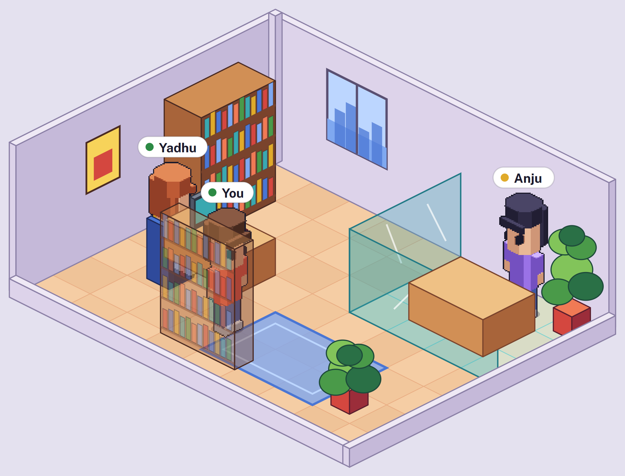
64×32  tile, 2:1 isometric | 64×128  avatar frame, feet at (32, 120) | 8 · 5  avatar directions · drawn | 4 · 2  furniture views · drawn | 384×2048  one animated avatar layer sheet | 3·2·1·½×  the four zoom steps
CONTENTS

Contents
START HERE
What this settles —
Reference games —
RULES
Grid and tiles R-01–05
Camera and zoom R-06–09
World scale R-10–13
Directions and views R-14–18
Furniture and props R-19–28
Floors, walls, rooms R-29–35
Characters R-36–46
Style limits R-47–54
HANDING OVER
What to deliver R-55–60
How it animates R-61–63
PLANNING
MVP asset list —
For approval —

In this Word version
The original is an interactive web page. Everything on it is here, and the parts that move or respond are handled like this:
- Links work. The contents entries jump to their section, and every rule reference such as R-24 jumps to that rule (Ctrl + click in Word).
- The checklist ticks. The boxes in "Before you open a pull request" are real Word checkboxes; click one to tick it.
- Two calculators recalculate. In the workload calculator and the furniture canvas calculator, change a shaded number, select the table and press F9 (Fn + F9 on many laptops).
- The avatar animations play. Every animation and direction from the page's player is an animated GIF. They play in Word for Microsoft 365 and Word on the web; older Word versions show the first frame.
- Views that switch on the page are shown in full. All four zoom levels, all six furniture presets and all seven sprite sheets are printed, with the readouts each one shows.
- Fonts travel with the file. Public Sans and Outfit are embedded, so the document looks the same on machines that do not have them installed.
Interactive original: claude.ai/artifact/FY2LpBh8CGMM5xzM2Chkdu
START HERE

What this rulebook settles
The FigJam board and the Hosting & Scale Plan disagree in a few places, and some things neither covers. Bold is the proposal.
TOPIC | FIGJAM BOARD | HOSTING PLAN §10 | RULEBOOK | ENGINE WORK
Rendering | "Playful, pixel-art aesthetic" | Open question: pixel art or illustrated | Pixel art drawn at 1×, shown only at set zoom steps | Phaser pixelArt: true, rounded camera position
Tile | 64 × 32, 2:1 | 96 × 48 (current backend default) | 64 × 32 | Set DEFAULT_OFFICE_CONFIG to 64 × 32. Furniture maths already reads tileWidth
Avatar frame | 64 × 128 | 96 × 128 | 64 × 128, feet at (32, 120) | None
Avatar directions | 8: five drawn, three flipped | 4: two drawn, two flipped | 8: five drawn, three mirrored | Pick facing from movement; walk diagonals along tile edges (2:1), not 45°
Furniture views | Iso front and iso back drawn, two flipped | 0° and 180° drawn, two flipped | Same, and items that can't mirror get four drawn views | Per-view frames in the manifest (planned)
Zoom | Four views: max zoom in, low, mid, max zoom out | Not covered | 3×, 2×, 1× (office default), ½× overview | Camera zoom steps; smooth filtering only at ½×
Animation | Static idle, breathing idle, walk, sit | Idle 4 frames at 6 fps, walk 8 at 12 fps | Idle 2 · walk 6 · sit 1 · work 4 · wave 6 | Walk playback rate follows movement speed
Head and hair | Long option lists | Every layer fully animated | Head, hair, hats, glasses are rigid: one frame per direction, carried by the body's head point | Read the body's per-frame head slice
Colour variants | 13 hair colours, 6 skin tones, clothing colours | Greyscale art, tinted at runtime | Key-ramp palette swap (5 steps) | Recolour at load time or in a shader
Palette and shading | Style references | Fixed light direction and outline rules | The art lead's decision. The rulebook sets only technical limits (R-47 to R-54) | None
Walls | Interior, exterior, corners | Left and right segments, cut-away | Walls on tile edges: 128 px behind the room, 16 px cut-away in front | New wall layer read from the office map
Desk items | Long stationery and kitchenware lists | Not covered | Surface props that snap to slots on furniture | Prop slots (stage 1)
START HERE

Reference games
The board sets the look. These games solved the same technical problems we have, and each rule that comes from one says so.
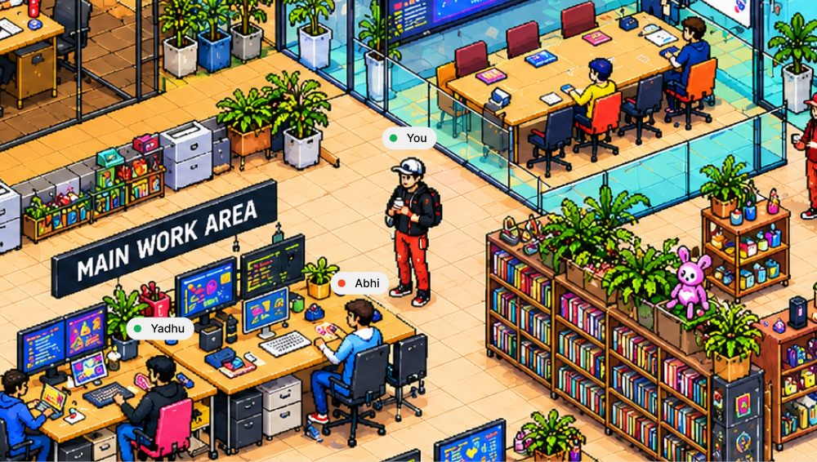  The board's target  FigJam · AI-generated V1, max zoom in  The look the art team is aiming for: warm, dense, pixel-art, isometric, with name tags over people.  USE IT FOR  Mood and density. The rules below make sure art in this style can be built, placed and animated. | 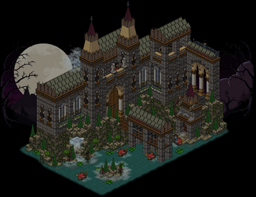  Habbo  2000 · social rooms  The closest relative to Aura: avatars and furniture in shared rooms on a 64 × 32 grid, with a fixed camera. Players build whole scenes like this one from stacked furniture.  WE TAKE  The tile size, mirrored avatar directions, and chair parts that draw over a seated avatar.  Screenshot: Wikipedia, low-resolution copy
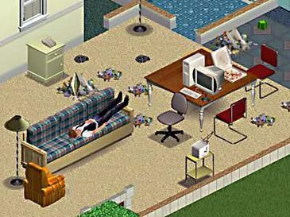  The Sims  2000 · life sim  Look at the bottom edge: the walls nearest the camera are cut down, so people inside are never hidden. Zoom moves in a few set steps.  WE TAKE  Front walls always render cut-away (R-30), and zoom has four set steps (R-07).  Screenshot: Wikipedia, low-resolution copy | 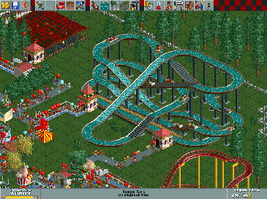  RollerCoaster Tycoon  1999 · park builder  Players can rotate this view, so every ride, tree and path piece needs four views drawn from four sides.  WE TAKE  The opposite choice. A fixed camera keeps every object at two drawn views (R-06).  Screenshot: Wikipedia, low-resolution copy
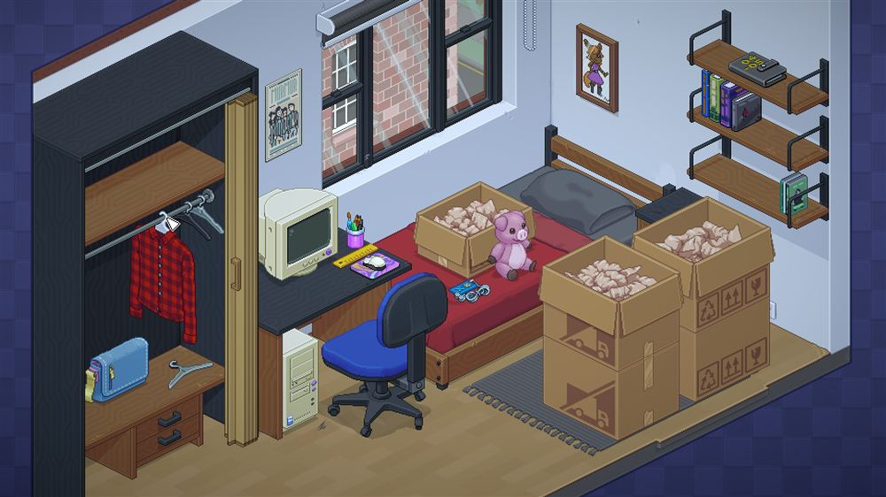  Unpacking  2021 · pixel-art rooms  A room built from many small objects that sit on shelves and desks: the monitor, pen pot and ruler are separate items on the desk.  WE TAKE  Mugs, notebooks and monitors are surface props placed on furniture, not floor items (R-26).  Screenshot: Steam store page | 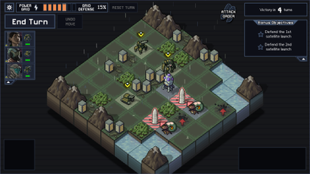  Into the Breach  2018 · isometric tactics  Every unit reads at a glance on a busy board, because the terrain stays quiet and units carry the contrast.  WE TAKE  A readability test, not a style: avatars must stay readable over the busiest floor and furniture (R-54).  Screenshot: Wikipedia, low-resolution copy
The game screenshots are low-resolution copies for internal reference only. Don't reuse them in Aura material.
RULES R-01 TO R-05

Grid and tiles
Everything in the world is measured in tiles. In code a position is a tile coordinate; the engine converts it to pixels. Artists only need the tile's pixel shape.
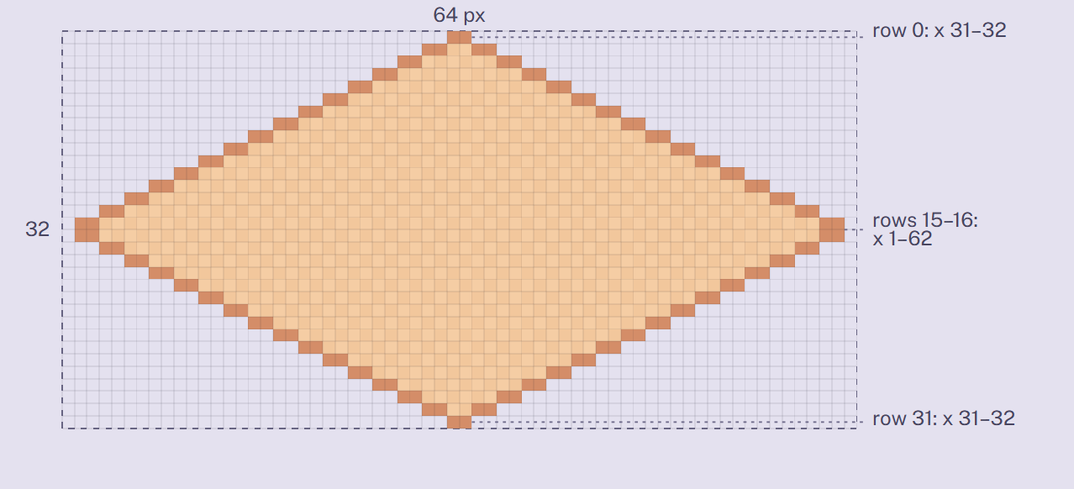  The 64 × 32 tile, one square per pixel. Each row grows by 2 px on each side, so the edges are clean 2:1 stairs. | 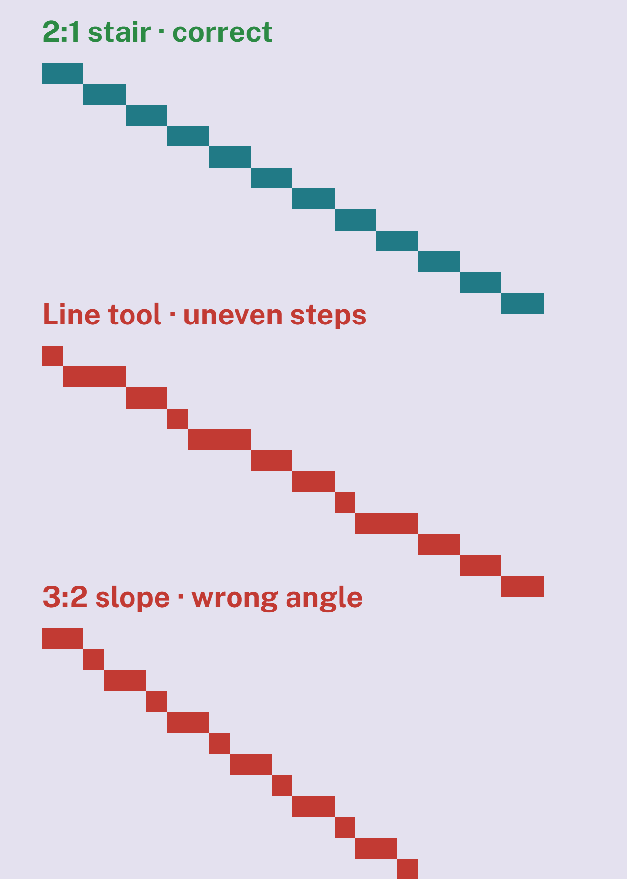  Only the first line tiles cleanly. Uneven steps from a line tool show up as jagged edges when tiles repeat.
R-01 | The tile is a 64 × 32 px diamond. Floor tiles, furniture footprints and wall lengths are all built from it.
R-02 | Draw every edge that follows the grid as a 2:1 stair: two pixels across, one pixel down. Vertical edges stay vertical.  Draw grid edges by hand or with a 2:1 brush. A line tool at 26.57° gives uneven steps.
R-03 | Tips are 2 px wide. The widest rows (15 and 16) run from x = 1 to x = 62, so the outermost columns stay empty.  Tiles placed 32 px across and 16 px down from each other then meet with no gaps and no doubled pixels. The tile template has this shape on a locked guide layer.
R-04 | Floor tiles fill the diamond exactly and repeat seamlessly on all four edges. Deliver four variants per material; the engine scatters them.
R-05 | A floor tile mirrored left to right must still tile. Use the mirror for the other plank or stripe direction instead of drawing a second set.
RULES R-06 TO R-09

Camera and zoom
The board asks for four zoom levels. Pixel art stays sharp only when each art pixel covers a whole number of screen pixels, so three of the four levels are whole-number scales, and the overview is the one exception.
In this Word version
On the page this is a zoom preview with four buttons. All four states are shown below, each with the readout and note the page shows for it.

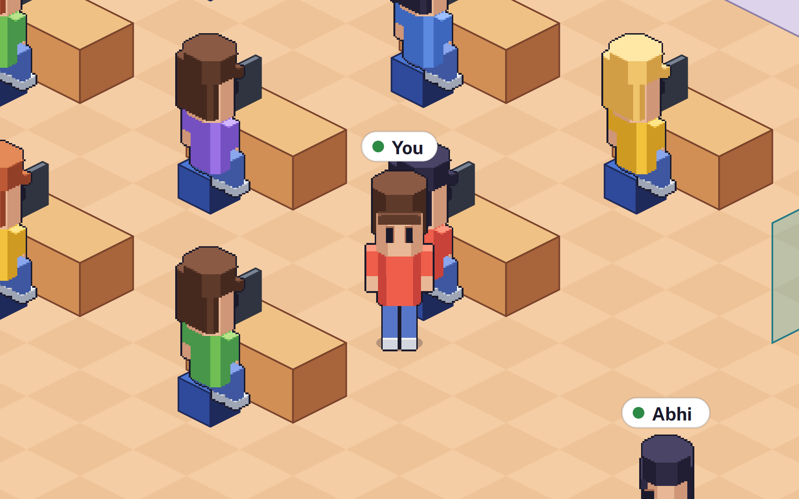  Max zoomed in · 3×  7.5 tiles across the screen · 288 px standing avatar · No whole office visible  Each art pixel is 3 × 3 screen pixels, so edges stay sharp. | 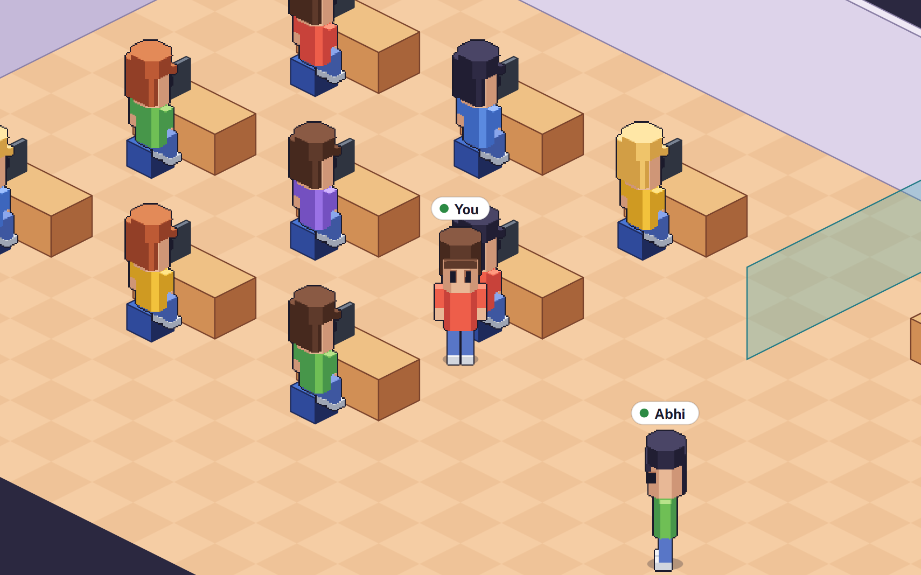  Low zoom out · 2×  11.3 tiles across the screen · 192 px standing avatar · No whole office visible  Each art pixel is 2 × 2 screen pixels, so edges stay sharp.
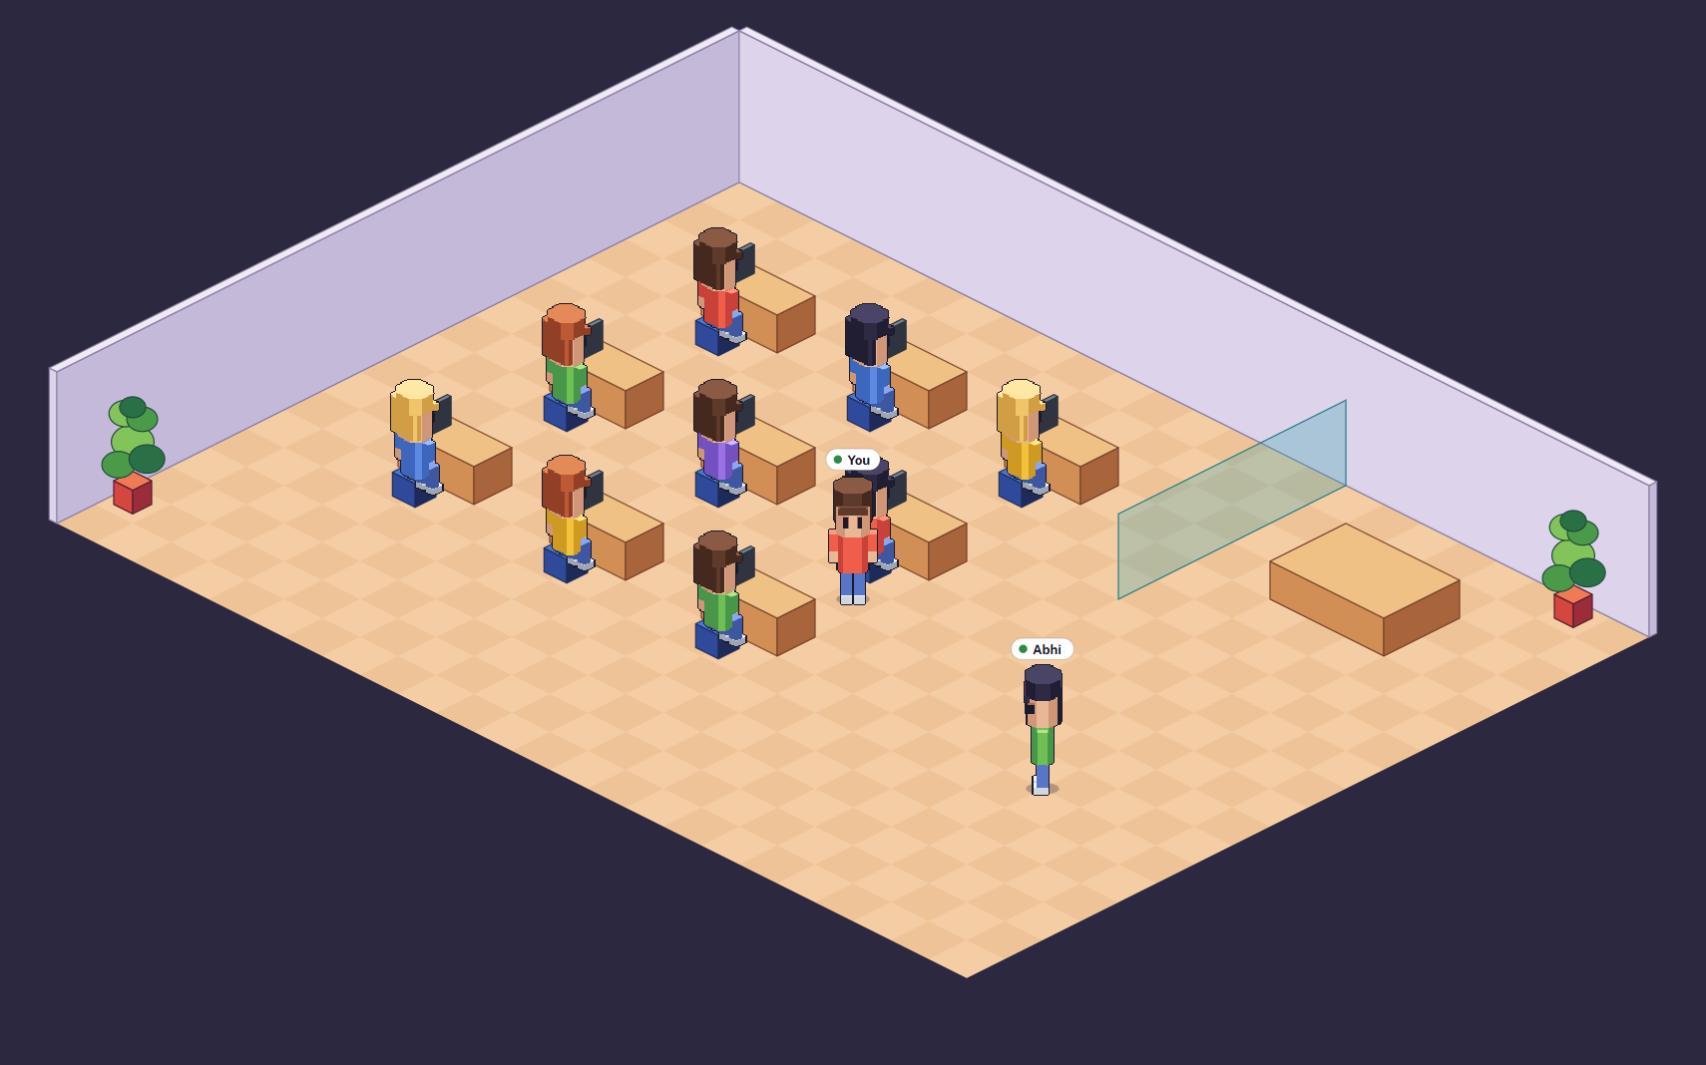  Mid zoom out · 1× (office default)  22.5 tiles across the screen · 96 px standing avatar · Yes whole office visible  Office default. Every art pixel is one screen pixel (two on a high-density screen). | 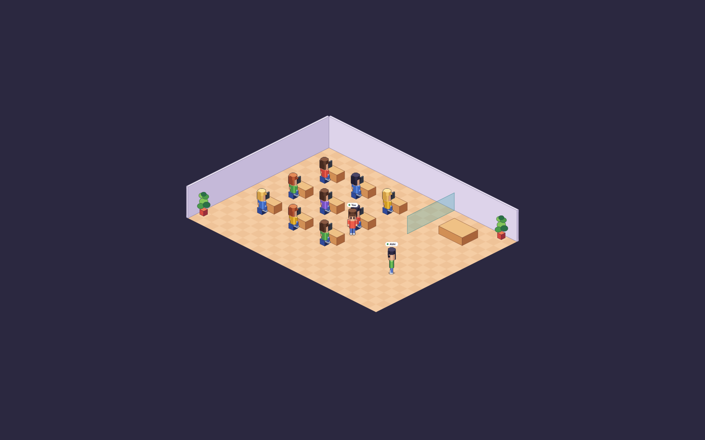  Max zoom out · ½×  45 tiles across the screen · 48 px standing avatar · Yes whole office visible  Overview only. Art is shrunk with smooth filtering, so fine pixel detail softens. Name tags stay readable because the engine draws them at screen size.
A 1440 × 900 laptop screen showing the default 24 × 18 office. On a high-density screen each level uses twice as many device pixels and stays just as sharp.
BOARD NAME | SCALE | USED FOR | TILE ON SCREEN | STANDING AVATAR
Max zoomed in | 3× | Meetings at a table, the avatar editor preview | 192 × 96 | 288 px
Low zoom out | 2× | Walking around one area | 128 × 64 | 192 px
Mid zoom out | 1× | Office default. The whole 24 × 18 office fits a 1440 px screen | 64 × 32 | 96 px
Max zoom out | ½× | Overview map of larger offices; smooth filtering | 32 × 16 | 48 px

R-06 | The camera is fixed and never rotates. Every object is drawn from the same corner of the room.  From RollerCoaster Tycoon, in reverse: a rotating camera would double the drawn views of every object.
R-07 | Zoom moves only in set steps: 3×, 2×, 1× and ½×. There's no free zoom slider.  Engine Camera zoom snaps to these steps, and camera scroll is rounded to whole art pixels so sprites don't shimmer while walking.
R-08 | Draw and export everything at 1×. Never deliver pre-scaled art; the engine does all scaling.
R-09 | Judge every asset at 1× first, because that's the office default. Detail that only shows at 3× is a bonus.  At ½× the engine shrinks art with smooth filtering. If floors or walls look muddy there in testing, we'll add hand-cleaned half-size versions of those first.
RULES R-10 TO R-13

World scale
One shared set of heights keeps a chair from one artist and a desk from another in proportion. Heights are art pixels from the floor to the top of the object, at 1×. The chart is a side view so the heights are easy to compare; in the game every object is drawn isometric.
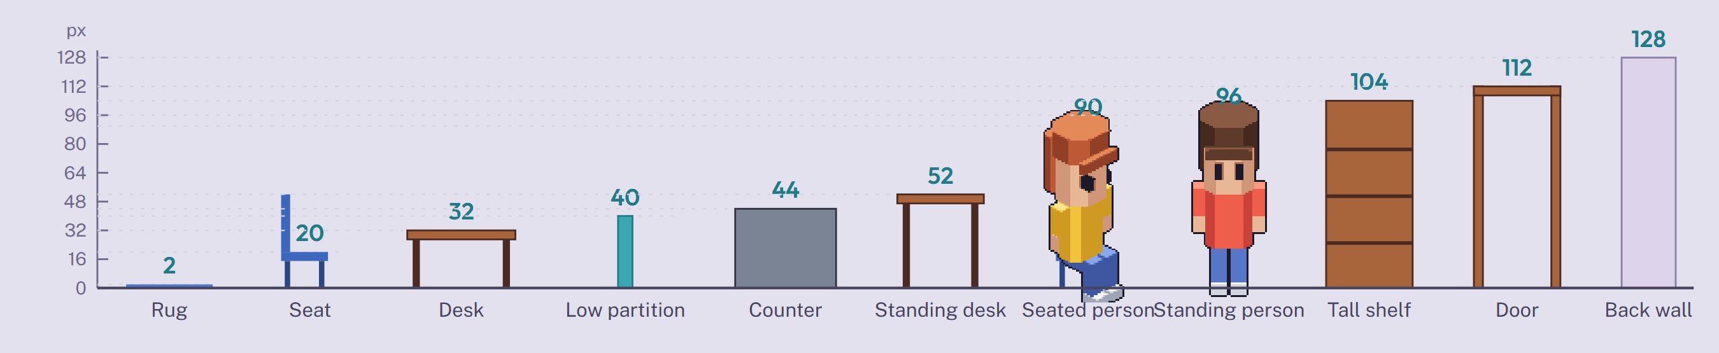
Side view, 1 px = 1 art pixel. Each number is the height above the floor that the art must match.
R-10 | Heights come from this chart; no item invents its own scale. The vertical scale is stylised: a 96 px person stands on a 64 × 32 tile, so people read clearly at 1×.
R-11 | Key heights: rug 2, seat 20, desk and table top 32, low partition 40, counter 44, standing desk 52, seated head 90, standing head 96, tall shelf 104, door 112, back wall 128.
R-12 | Items on open floor stay under 112 px, the height of a door. Taller items (bookcases, lockers, fridges, tall plants) are against-wall items.  Builder Against-wall items can only be placed on tiles that touch a back wall.
R-13 | Low partitions and cubicle dividers are 40 px or less, so a seated person (head at 90 px) always shows above them.
RULES R-14 TO R-18

Directions and views
The board's direction sheet already matches the game's controls: arrow keys and WASD move in eight screen directions. On the right, the same eight directions as isometric pixel sprites.
About the sample character on this page
It's a blocky stand-in, generated in code from simple 3D volumes, to show angles, proportions, frame sizes and animation timing. It isn't a style proposal; the art team draws the real character.

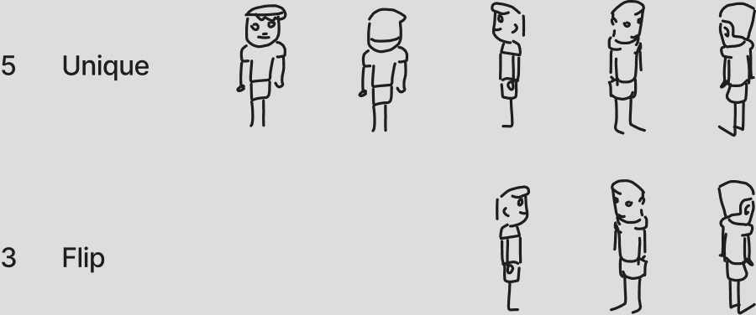  The board's sketch: 5 unique views, 3 flipped. | 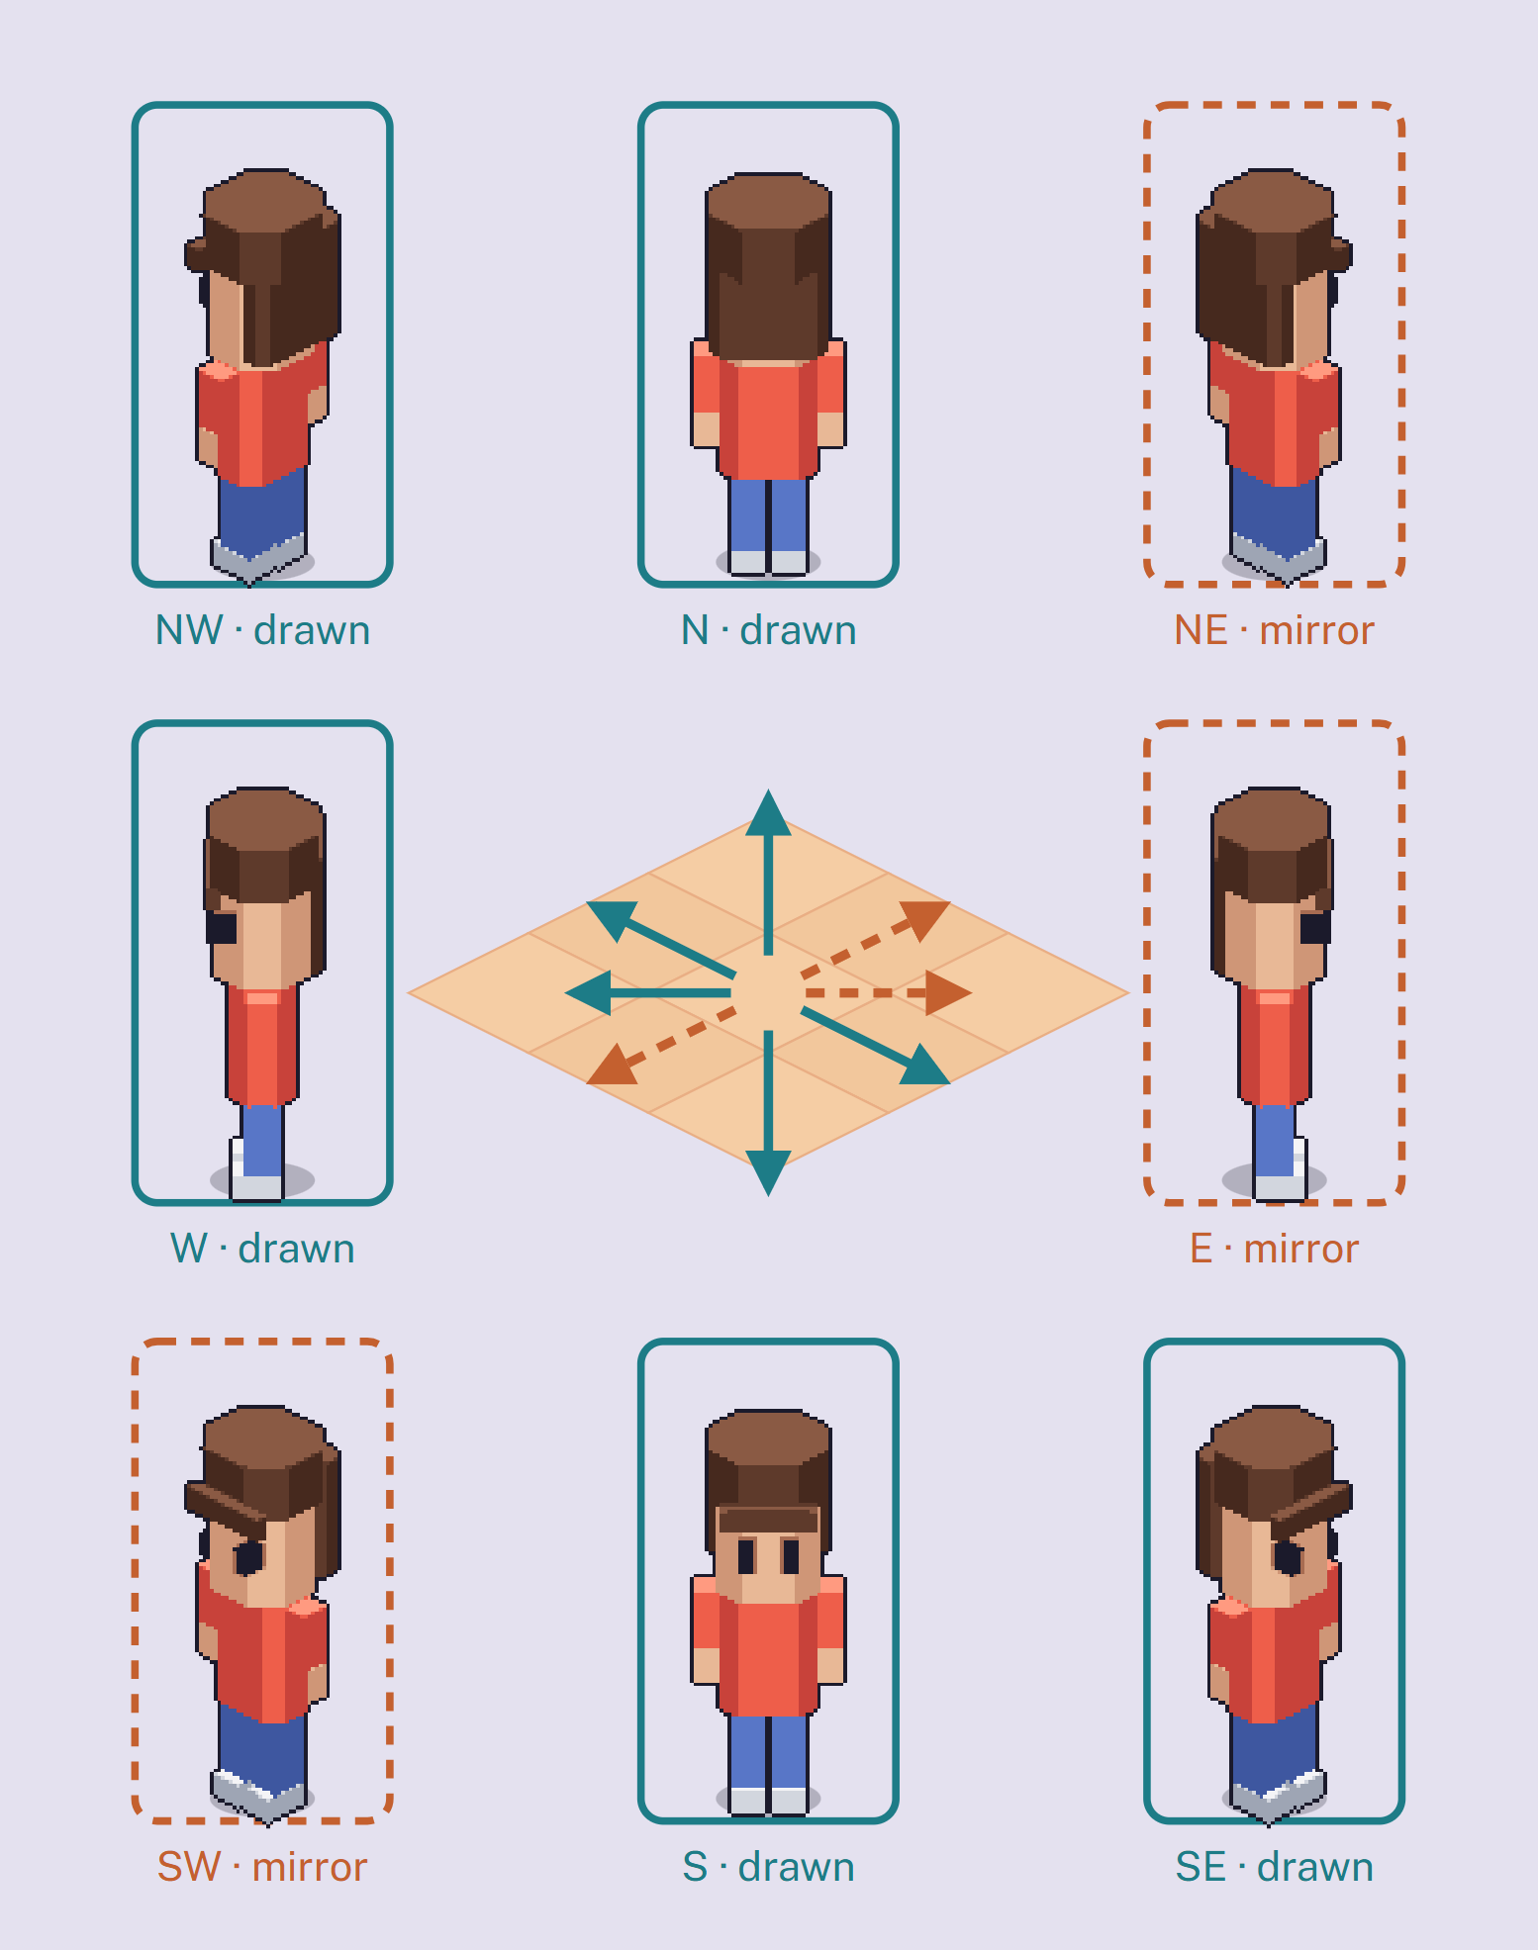  The same eight directions as 64 × 128 sprites. Teal is drawn, orange is the drawn sprite mirrored.
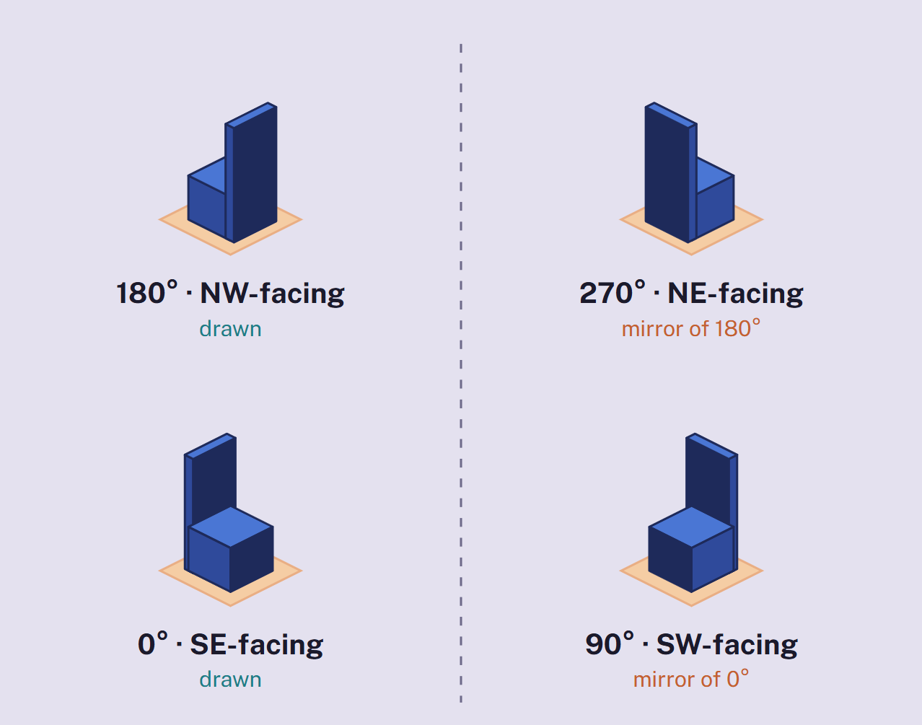
Furniture: draw the SE-facing and NW-facing views. The other two are the same pixels mirrored.
CODE | BOARD NAME | KEYS | AVATAR | FURNITURE
s | Flat front | S | drawn | —
se | Iso front-right | S + D | drawn | 0° drawn
e | Flat right side | D | mirror of w | —
ne | Iso back-right | W + D | mirror of nw | 270° mirror
n | Flat back | W | drawn | —
nw | Iso back-left | W + A | drawn | 180° drawn
w | Flat left side | A | drawn | —
sw | Iso front-left | S + A | mirror of se | 90° mirror

R-14 | Avatars face eight directions. Draw s, se, w, nw and n; the engine mirrors e, sw and ne.  Habbo mirrors avatar directions the same way instead of drawing all eight.
R-15 | Furniture has four rotations. Draw the SE-facing view (0°) and the NW-facing view (180°); 90° and 270° are their mirrors.
R-16 | Mirroring flips everything: text, logos, side partings, a watch on one wrist, a single pocket. Keep avatar layers left-right symmetric where you can.  Items that can't mirror (signs with words, an L-desk with its return on one side, a chaise sofa) get all four views drawn and are marked mirror: false.
R-17 | The se and nw views face along tile edges, at the 2:1 angle (26.6° from horizontal), not at 45°.  Engine Diagonal key presses currently move at 45°. They should move along tile edges so the drawn view matches the path.
R-18 | Sitting uses only the four tile-edge directions, because chairs sit on the grid. Draw se and nw sitting poses; the rest are mirrors.
RULES R-19 TO R-28

Furniture and props
A furniture sprite's canvas size comes from its footprint and height, so the engine can place it with no hand-tuned offsets. Pick a footprint below to see the canvas the template will give you.
In this Word version
On the page this is a canvas builder: six presets, a Columns (down-right) picker and a Rows (down-left) picker (1 to 4 each), and an Object height slider (0 to 160 px in 2 px steps, starting at 32 px). Below are all six presets as the page draws them, then a calculator table that works in Word for any footprint.

Dashed: canvas edge. Teal diamond: footprint at floor level. Red cross: the anchor, the footprint's top tip.
Desk  2 × 1 footprint · 32 px tall  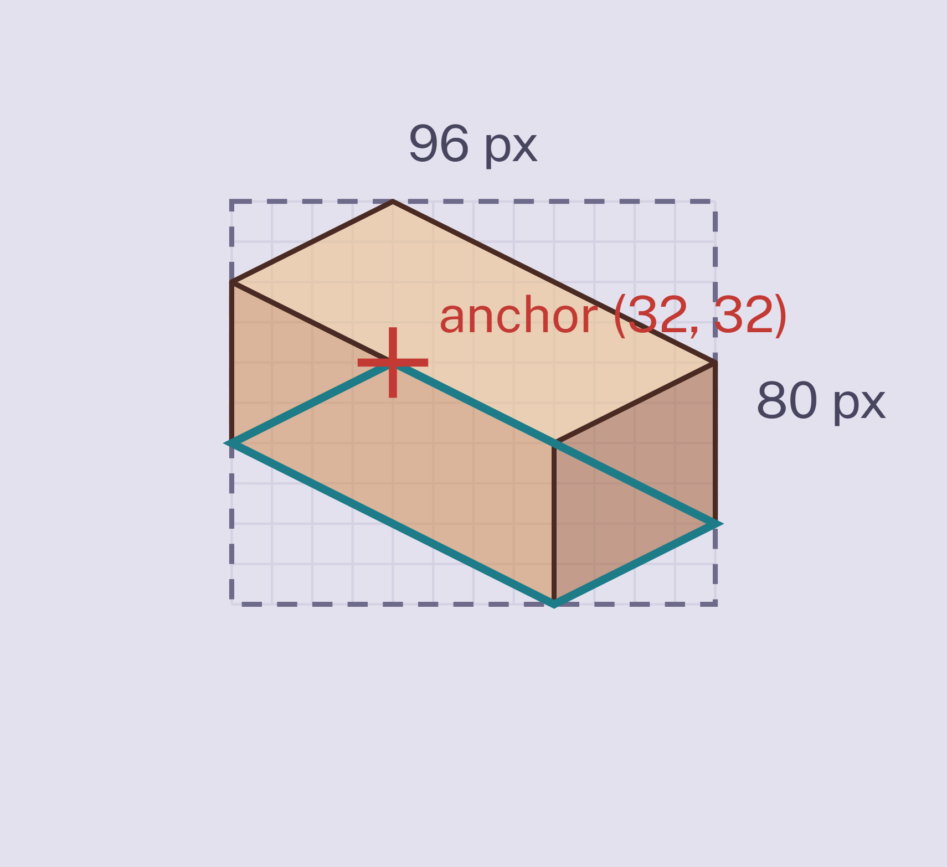  96 × 80 canvas (px) · (32, 32) anchor · 2 × 1 footprint  ■ Template: tpl-furniture-2x1.aseprite · sheet 192 × 80 for 2 views  ■ Rotating 90° swaps it to 1 × 2; the mirrored view covers that. | Office chair  1 × 1 footprint · 52 px tall  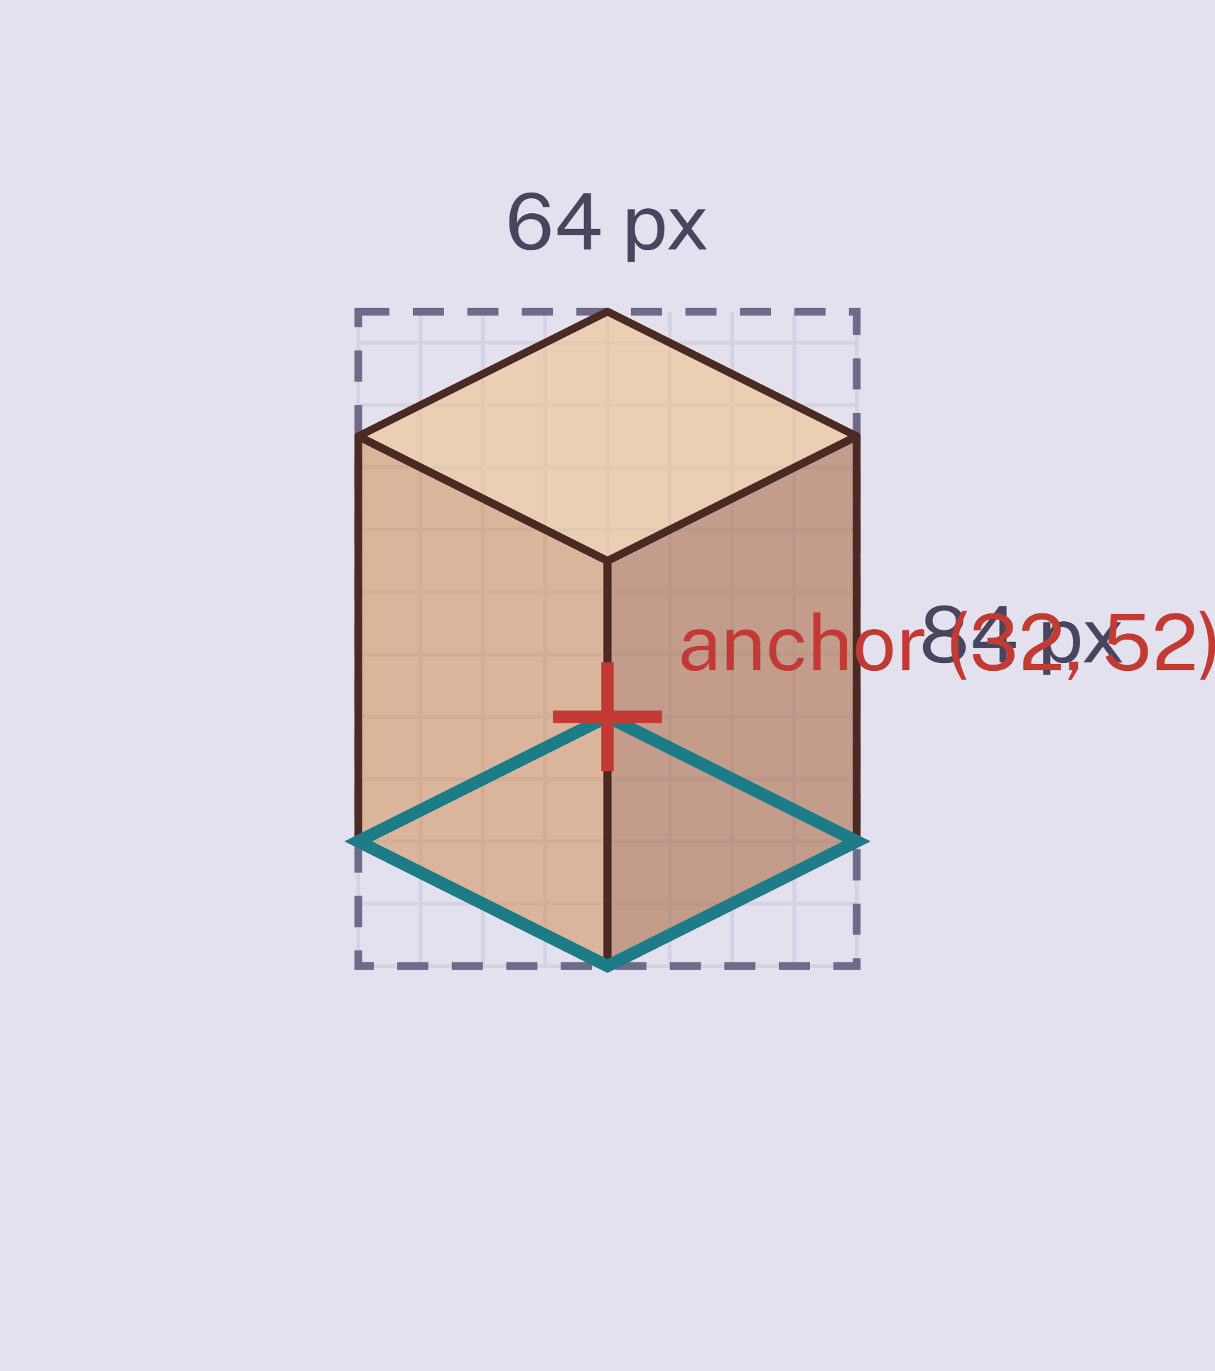  64 × 84 canvas (px) · (32, 52) anchor · 1 × 1 footprint  ■ Template: tpl-furniture-1x1.aseprite · sheet 128 × 84 for 2 views  ■ Within all size rules. | Bookshelf  2 × 1 footprint · 104 px tall  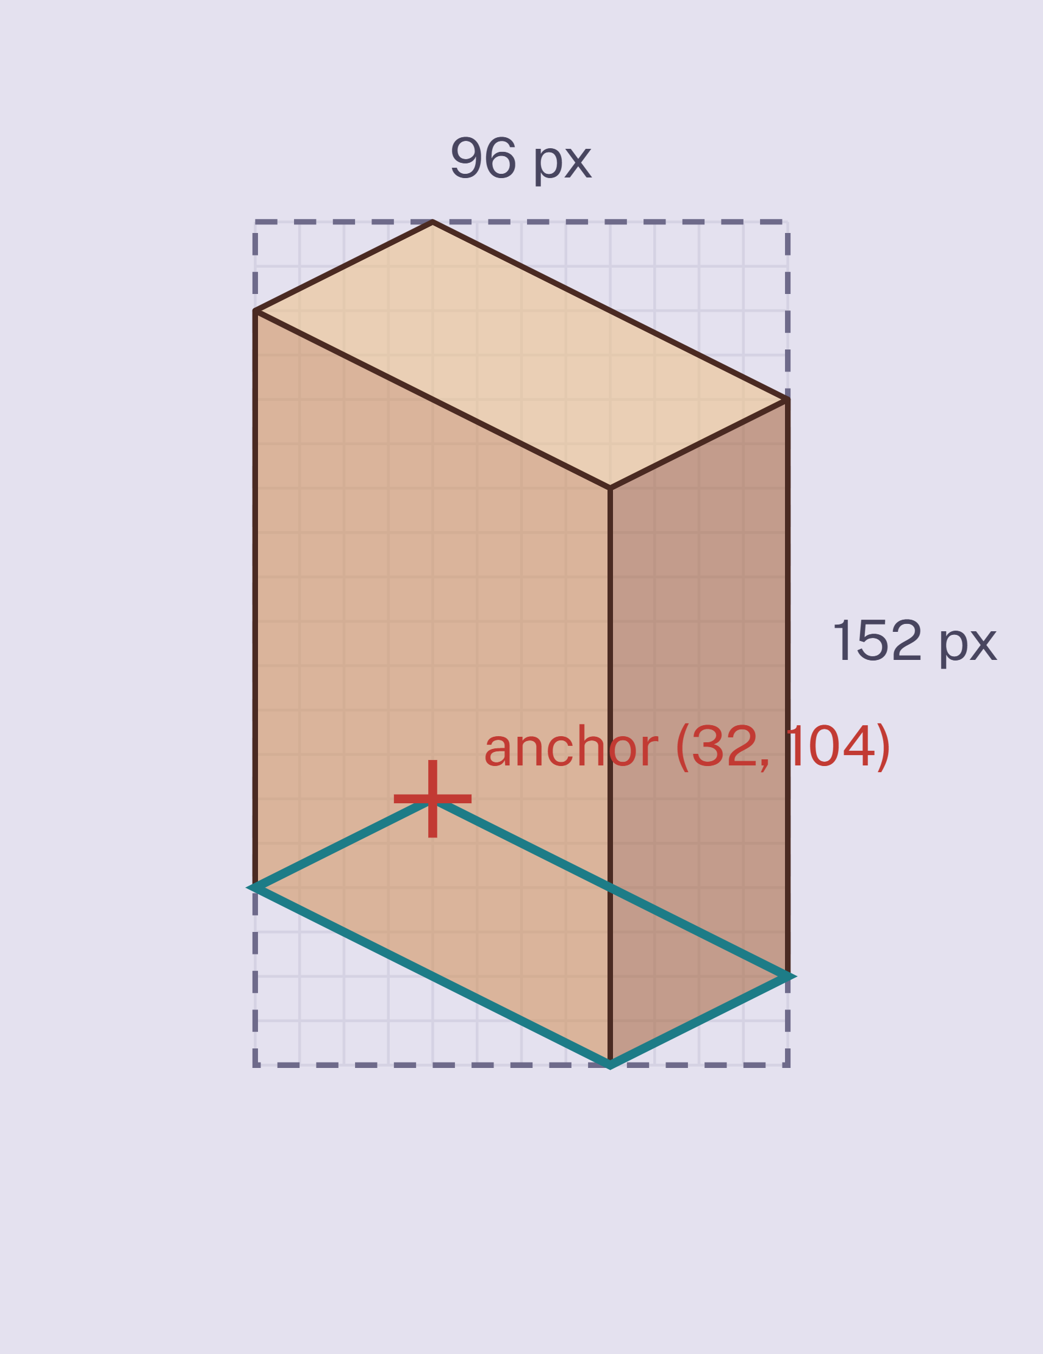  96 × 152 canvas (px) · (32, 104) anchor · 2 × 1 footprint  ■ Template: tpl-furniture-2x1.aseprite · sheet 192 × 152 for 2 views  ■ Rotating 90° swaps it to 1 × 2; the mirrored view covers that.
Conference table  3 × 2 footprint · 32 px tall  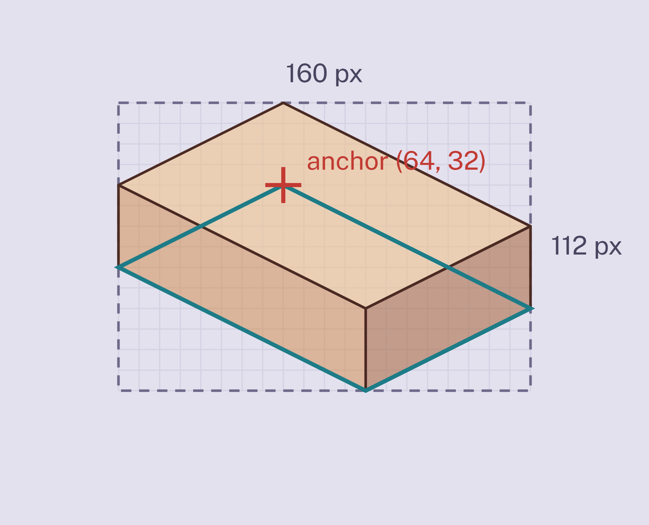  160 × 112 canvas (px) · (64, 32) anchor · 3 × 2 footprint  ■ Template: tpl-furniture-3x2.aseprite · sheet 320 × 112 for 2 views  ■ Rotating 90° swaps it to 2 × 3; the mirrored view covers that. | Tall plant  1 × 1 footprint · 104 px tall  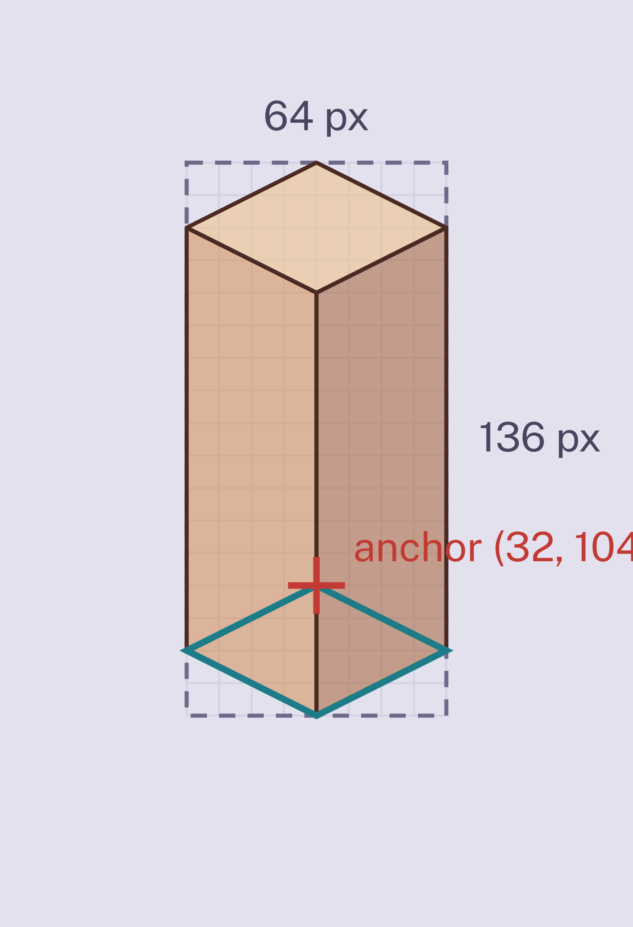  64 × 136 canvas (px) · (32, 104) anchor · 1 × 1 footprint  ■ Template: tpl-furniture-1x1.aseprite · sheet 128 × 136 for 2 views  ■ Within all size rules. | Rug  3 × 2 footprint · 2 px tall  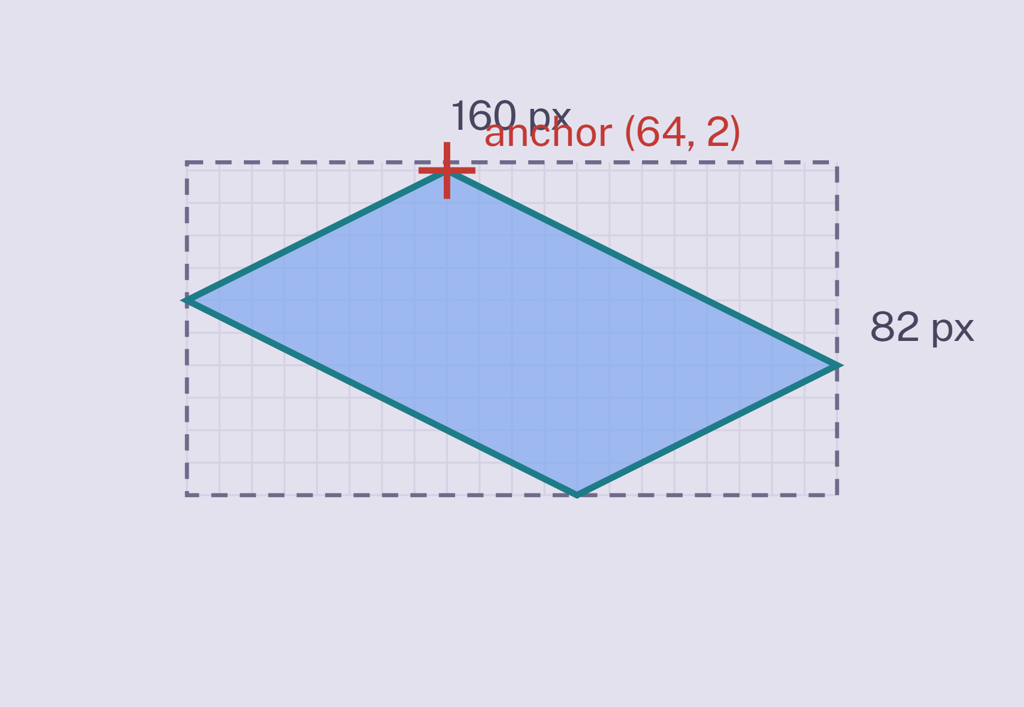  160 × 82 canvas (px) · (64, 2) anchor · 3 × 2 footprint  ■ Template: tpl-furniture-3x2.aseprite · sheet 320 × 82 for 2 views  ■ Decal (R-27): no blocking, always under furniture and avatars.  ■ Rotating 90° swaps it to 2 × 3; the mirrored view covers that.

Canvas calculator
Shaded cells are inputs. Change a number, select the table and press F9 to recalculate. Canvas width = (columns + rows) × 32; canvas height = (columns + rows) × 16 + height; anchor = (rows × 32, height); the sheet holds 2 views side by side (R-19, R-20).
ITEM | COLUMNS | ROWS | HEIGHT PX | CANVAS W | CANVAS H | ANCHOR | SHEET (2 VIEWS)
Desk | 2 | 1 | 32 | 96 | 80 | (32, 32) | 192 × 80
Office chair | 1 | 1 | 52 | 64 | 84 | (32, 52) | 128 × 84
Bookshelf | 2 | 1 | 104 | 96 | 152 | (32, 104) | 192 × 152
Conference table | 3 | 2 | 32 | 160 | 112 | (64, 32) | 320 × 112
Tall plant | 1 | 1 | 104 | 64 | 136 | (32, 104) | 128 × 136
Rug | 3 | 2 | 2 | 160 | 82 | (64, 2) | 320 × 82
Your item | 1 | 1 | 32 | 64 | 64 | (32, 32) | 128 × 64
Size checks from the page: footprints longer than 4 in total must be 36 px tall or less (R-22); 112 px or taller is against-wall only (R-12); 2 px or less is a decal (R-27); canvases taller than 256 px are too tall; a non-square footprint rotated 90° swaps columns and rows, which the mirrored view covers.
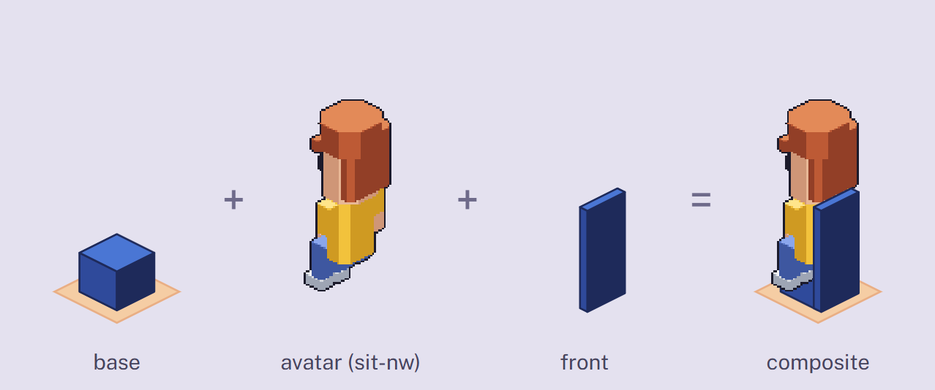  R-24: a NW-facing chair. The backrest is between the camera and the person, so it goes on the front layer. | 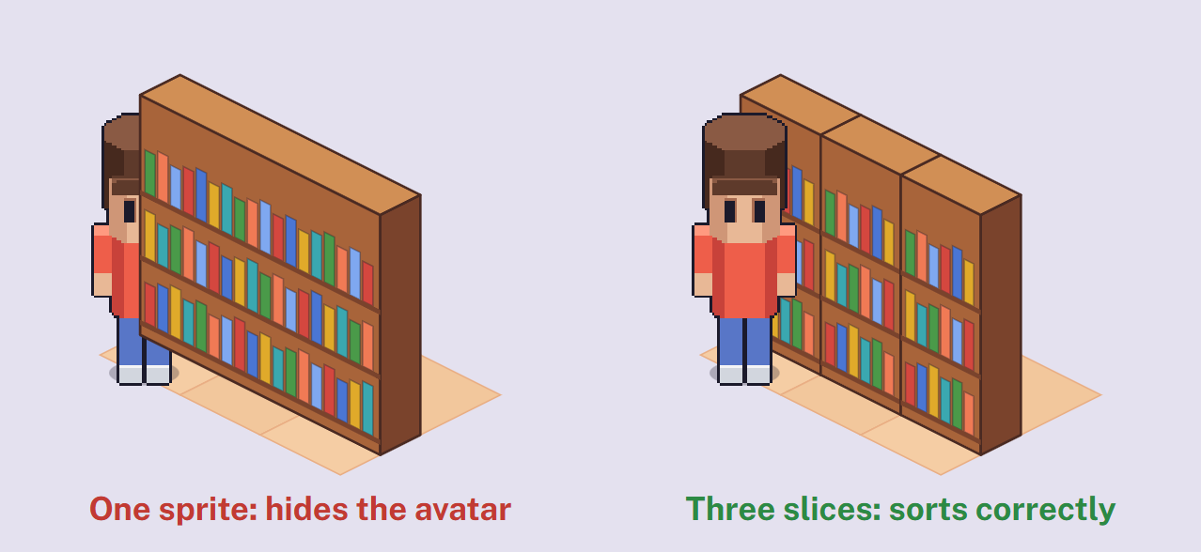  R-22: a long, tall item is sorted by its front-most tile, so it draws over someone standing in front of its other end.
R-19 | Canvas width is (columns + rows) × 32 px. Canvas height is (columns + rows) × 16 px plus the object's height. Start from the template for the footprint and never resize the canvas.
R-20 | The anchor is the footprint's top tip at floor level, at (rows × 32, object height) from the canvas's top-left. It's preset in the template as a slice named anchor.
R-21 | Stay inside the footprint's column. Nothing hangs past the footprint's sides or in front of it. If a plant's leaves need more room, give it a bigger footprint.  Depth sorting assumes every pixel belongs above its own tiles; overhangs get cut by neighbours.
R-22 | Footprints longer than 4 in total (3 × 2, 4 × 2…) must be 36 px tall or less, or be delivered as one-tile slices.
R-23 | The contact shadow is part of the sprite and stays inside the footprint diamond.
R-24 | Seats have two layers per view: base (seat and legs, drawn behind a seated avatar) and front (backrest or armrests that cover the avatar). A seat slice marks where the avatar's feet point goes when seated.  Habbo splits chairs the same way.
R-25 | Items with states put each state on its own Aseprite tag: off, on, open. Animated states loop at most 4 frames at 4 fps.
R-26 | Things that sit on furniture (monitors, laptops, mugs, desk plants, stationery) are surface props, not floor furniture. Prop canvas is at most 32 × 32 px with the anchor at the bottom centre. Host furniture marks where props can go with surface slices.  Engine · stage 1 Prop slots on furniture. Today's 1 × 1 floor monitor (electronics-monitor-01) becomes a prop. From Unpacking.
R-27 | Rugs and floor markings are decals: at most 2 px tall, never block movement, and always drawn under furniture and avatars.
R-28 | Wall-mounted items (TVs, posters, clocks, wall shelves) hang on wall segments, not tiles. Their canvas is one segment (32 px) or two (64 px) wide, drawn flat on the wall's 2:1 plane.
RULES R-29 TO R-35

Floors, walls and rooms
Walls are the most likely thing to hide people in an isometric office. These rules keep every avatar visible without giving up walls.
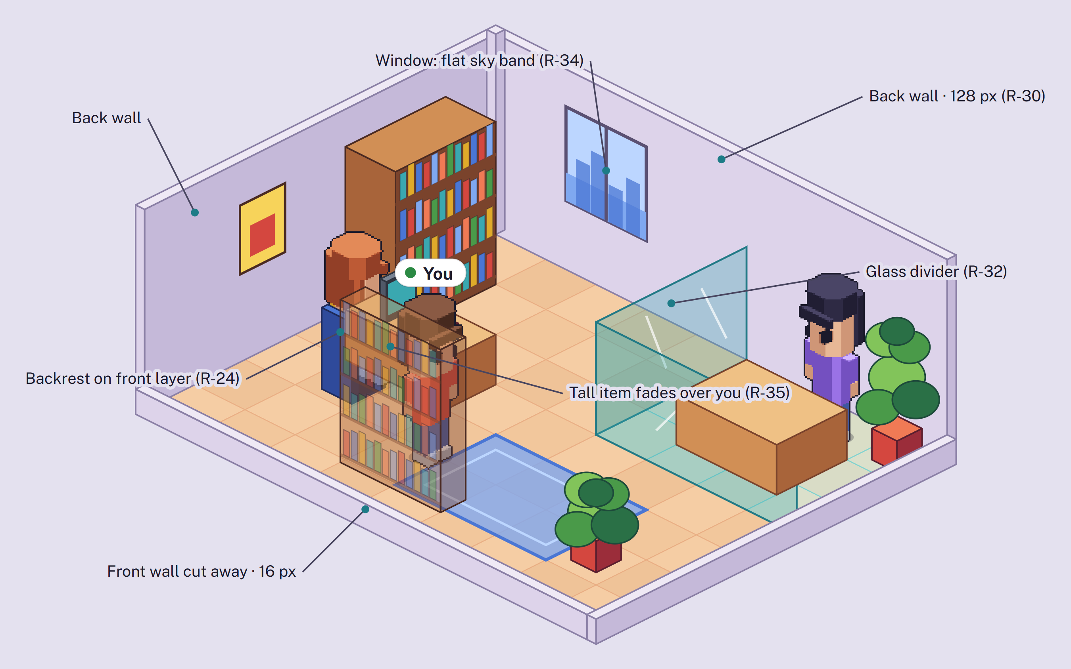
Back walls stand full height; front walls are cut away; a glass divider keeps the meeting room visible; the shelf in front of "You" fades.
R-29 | Walls stand on tile edges, not on tiles. A segment is one tile edge long: 32 px across and 16 px of rise along the 2:1 slope.  Engine A wall layer read from the office map, separate from furniture.
R-30 | Every wall piece comes in two heights: full (128 px plus a 6 px top cap) and cut-away (16 px). Walls behind a room show full height; walls between the camera and the room always show cut-away.  From The Sims' cut-away walls.
R-31 | A wall kit per material: straight, outer corner, inner corner, end cap, doorway (one tile) and window (one tile), each at both heights, in the / direction. The \ direction is a mirror unless the material can't mirror.
R-32 | The default room divider is glass or a low partition (40 px or less). Never show more than two glass planes stacked.
R-33 | Doors are open doorways in the MVP: the frame is a wall piece with no door leaf. Sliding and swinging doors come later.
R-34 | Windows show a flat sky or skyline band (from the board's Environment list) that doesn't change with position.
R-35 | Tall furniture in front of your own avatar fades to 40% opacity, as walls do in Diablo II. Keep tall objects solid and readable; don't build transparency into opaque art.
RULES R-36 TO R-46

Characters
Avatars are built from layers that share one 64 × 128 frame. Animated layers need every frame; rigid layers need one frame per direction, and the engine moves them with the body.
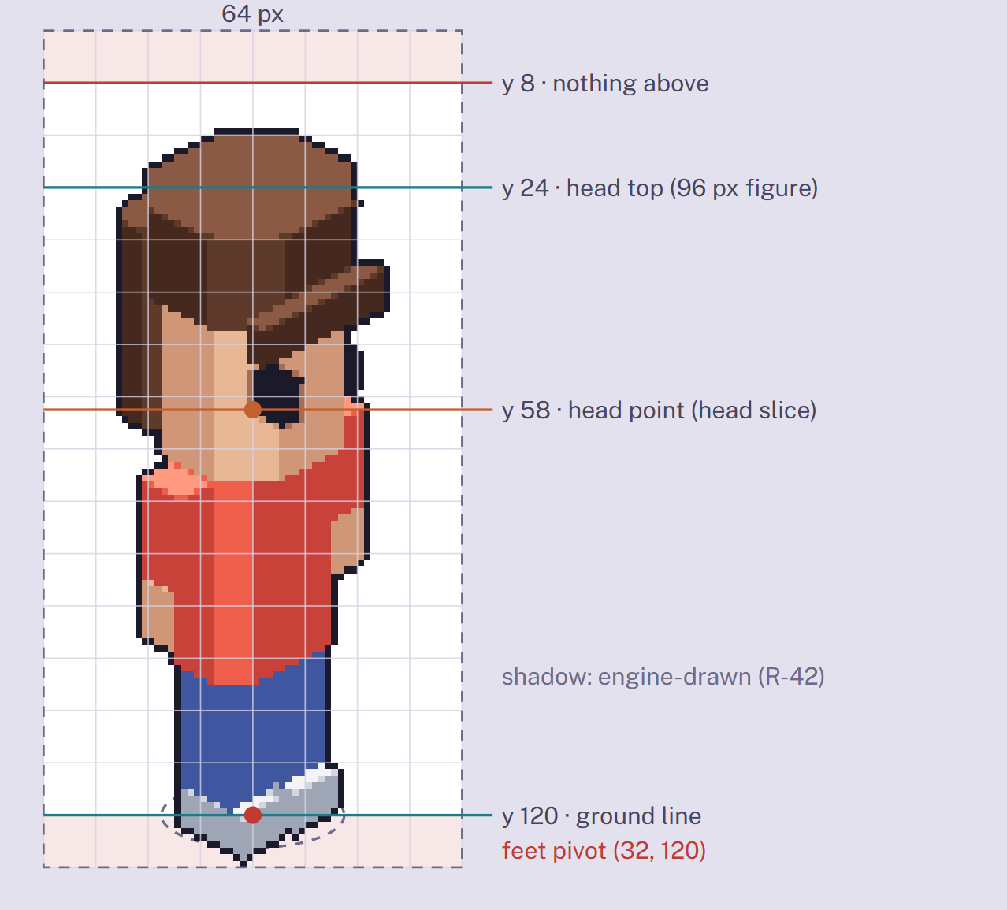  The 64 × 128 frame, shown at 3×, with a se sprite. The grid is 8 px. | 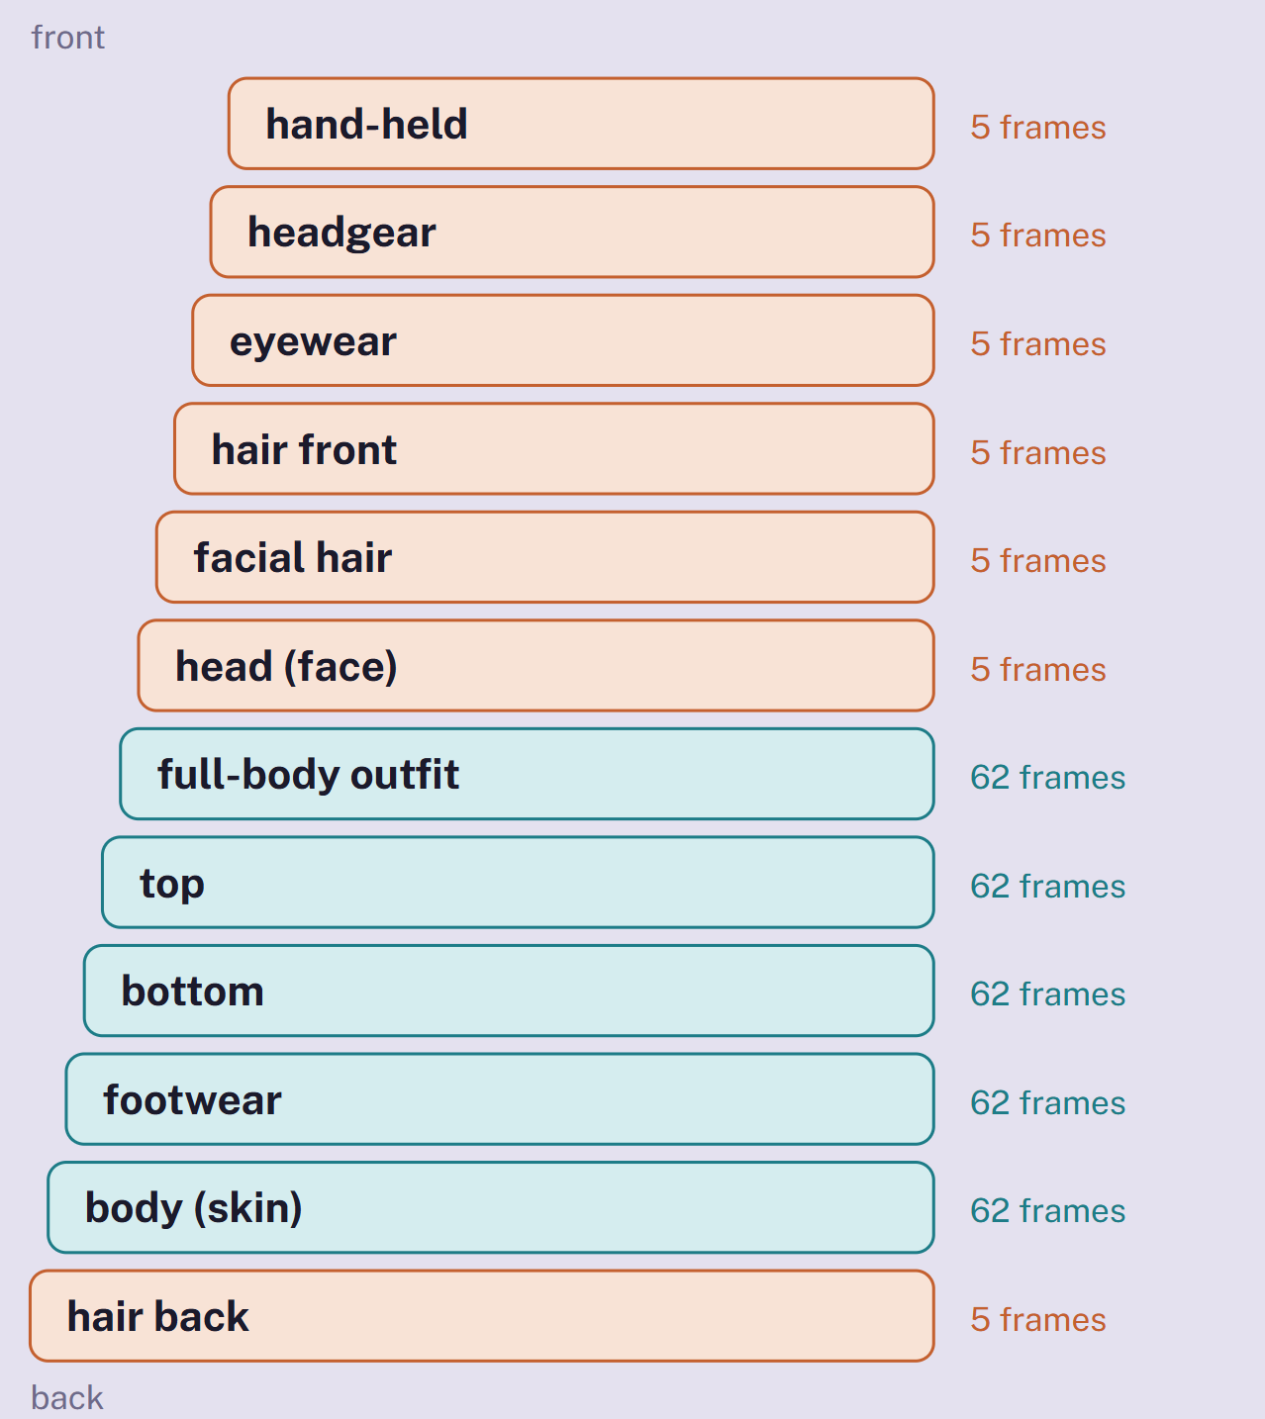  Layer order facing the camera, back to front. Teal layers animate (62 frames); orange layers are rigid (5 frames).
R-36 | The frame is 64 × 128 px. The feet pivot is at (32, 120), the point on the ground between the feet. Leave the 8 px below the ground line empty.
R-37 | A standing figure is 96 px from feet to top of head (y = 24). Hair, hats and raised arms may reach y = 8; nothing goes above that.
R-38 | One neutral body base for the MVP, and everyone is the same height, as the board decided. Proportions are the art team's choice within the frame.
R-39 | Animated layers (body, top, bottom, footwear, full-body outfit) deliver every frame of every animation. Use Aseprite linked cels where frames repeat.
R-40 | Rigid layers (head, hair, facial hair, headgear, eyewear) deliver one frame per drawn direction, drawn on the reference pose (idle frame 1). The engine moves them with the body's head slice, frame by frame.  Something that needs its own motion, like a swinging ponytail, becomes an animated layer.
R-41 | Long hair and capes split into back and front pieces: back draws behind the head, front draws over it.
R-42 | Don't draw the ground shadow. The engine draws one 28 × 10 px shadow per avatar.
R-43 | Colour-changeable parts use the key ramps only (see below). Fixed details such as logos and buttons are drawn in their final colours.
R-44 | Full-body outfits (dresses, jumpsuits, branded uniforms) hide the top and bottom layers, as the board specifies. They still draw over the body and footwear.
R-45 | Facing away (n, ne, nw), the order changes: back hair draws after the head, and hand-held items move behind the body.
R-46 | Crowd extras (event audiences, the board's "random people sitting in greys") are one-layer sprites, seated, in two drawn directions. Only people you know get full avatars.

Animations for the MVP
TAG | DIRECTIONS | FRAMES | FPS | PLAYS | DRAWN FRAMES PER ANIMATED LAYER
idle | 8 (5 drawn) | 2 | 2 | Loop. Frame 2 lowers the upper body 1 px (breathing) | 10
walk | 8 (5 drawn) | 6 | 10 | Loop. Rate follows movement speed so feet don't slide | 30
sit | 4 tile-edge (2 drawn) | 1 | — | Hold | 2
work | 4 tile-edge (2 drawn) | 4 | 8 | Loop. Seated typing | 8
wave | 3 facing camera: s, se, sw (2 drawn) | 6 | 10 | Once, then back to idle. Avatar turns toward the camera first | 12
Total per animated layer option (rigid layers need 5) |  |  |  |  | 62
Later (from the board's Extended and Premium lists): thinking, jump, dance, laugh and emotes. Each adds frames to animated layers only.

Colour: key ramps and palette swap
Draw colour-changeable areas with a 5-step key ramp. The engine swaps each key step for the matching step of the colour the user picks, so one drawing gives every colour on the board with its shading intact. The art team defines the real colour ramps; the colours below are only examples.
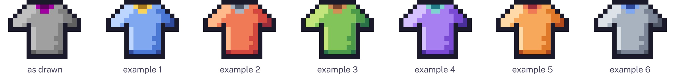
Left: a T-shirt as drawn, with the primary key ramp (pure greys) and the secondary key ramp (magenta) on the collar. The rest: the same pixels after the swap.
KEY RAMP | STEPS, DARKEST TO LIGHTEST | USED FOR
Primary | ■ #404040 ■ #606060 ■ #808080 ■ #a0a0a0 ■ #c0c0c0 | Skin on body and head; hair colour on hair and facial hair; main colour on clothes
Secondary | ■ #400040 ■ #600060 ■ #800080 ■ #a000a0 ■ #c000c0 | Trim and second colour on two-tone clothes
Pure greys (equal red, green and blue) are reserved on avatar layers. A grey that must stay grey, like a metal zip, needs a slight tint.

Workload calculator
Set how many options each slot gets. Defaults follow the board's Essential list. The last figure shows what the same set would cost if every layer were fully animated, which is what the hosting plan assumed.
Shaded cells are inputs (options 0 to 60; pace 10 to 60 frames per artist-day). Change a number, select the table and press F9 to recalculate. The figures below are the page's defaults.
SLOT | KIND | OPTIONS | FRAMES EACH | DRAWN FRAMES
Body base | animated | 1 | 62 | 62
Tops | animated | 6 | 62 | 372
Bottoms | animated | 4 | 62 | 248
Footwear | animated | 3 | 62 | 186
Full-body outfits | animated | 0 | 62 | 0
Head (face) | rigid | 1 | 5 | 5
Hairstyles | rigid | 10 | 5 | 50
Long-hair back pieces | rigid | 3 | 5 | 15
Facial hair | rigid | 4 | 5 | 20
Headgear | rigid | 3 | 5 | 15
Eyewear | rigid | 2 | 5 | 10
Frames to draw |  |  |  | 983
Days for one artist at this pace | Pace (frames per artist-day) → | 30 |  | 33 days
If every layer animated |  |  | × 62 | 2,294
RULES R-47 TO R-54

Style limits
Palette, shading style, outlines, contrast and level of detail are the art team's decisions. These rules list only what the engine needs from any style.
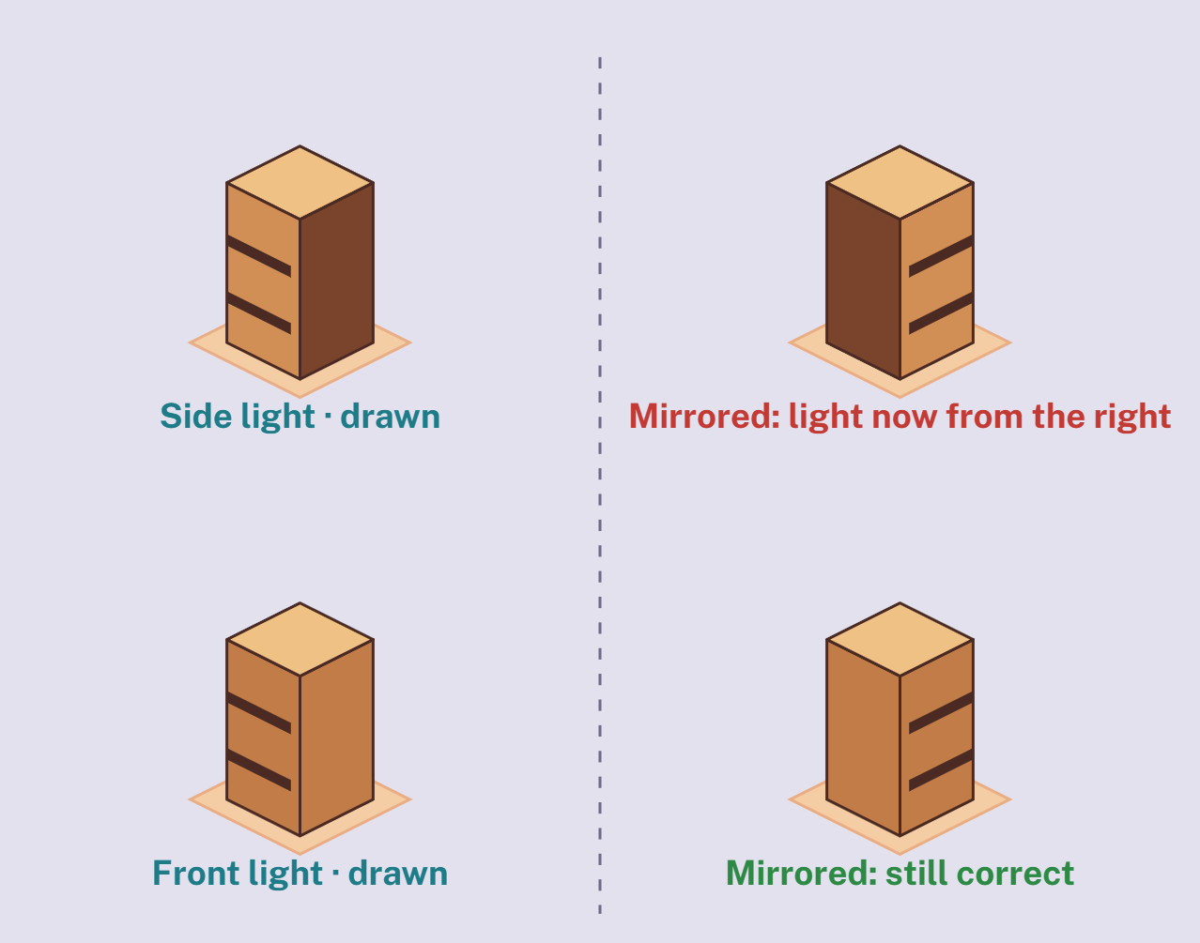  R-48: mirroring flips the light. Side light (top row) changes between the drawn and mirrored view; front light (bottom row) doesn't. | Owned by the art lead  Palette and colour ramps · light direction · shading style · outline colour and weight · contrast between floor, furniture and people · level of detail at 1×. The board's references and V1 image are the starting point.

R-47 | Art direction belongs to the art lead. Nothing in this rulebook sets colours or shading style.
R-48 | Use one light direction for the whole game, chosen by the art lead. Mirrored views flip the light: light from the front or top looks right in mirrors; light from one side doesn't, unless all views are drawn.
R-49 | Hard outer edges. Pixels on a sprite's outer edge are fully opaque or fully transparent. Only shadows, glass and light effects use partial transparency.
R-50 | One pixel size everywhere. Don't scale, rotate or distort art in the editor; redraw it at the new size instead.
R-51 | Outlines, if the style uses them, sit inside the canvas or frame and count toward its size limits.
R-52 | No text or logos baked into anything that mirrors. Signs with words get every view drawn, or use an engine label like the zone names.
R-53 | Repeating materials repeat on the grid: floor patterns every 64 × 32 tile, wall patterns every 32 px segment.
R-54 | Readability test: an avatar must stay easy to pick out at 1× over the busiest floor and in front of the busiest furniture. How the style achieves that is up to the art team.  From Into the Breach.
RULES R-55 TO R-60

What to deliver
Artists deliver Aseprite source files. A build script exports them to sprite sheets and JSON; nobody lays out sheets by hand. The sizes below are what the export produces, so you can check your file is complete.
Avatar · animated layer  Body, top, bottom, footwear, full-body outfit  File top-hoodie-01.aseprite  Canvas 64 × 128  Tags 16 (idle, walk × 5 dirs; sit, work × 2; wave × 2)  Frames 62  Sheet 384 × 2048 (6 × 16 cells)  Slices head, per frame (body file only) | Avatar · rigid layer  Head, hair, facial hair, headgear, eyewear  File hair-bob-01.aseprite  Canvas 64 × 128  Tags ref-s, ref-se, ref-w, ref-nw, ref-n  Frames 5 (10 with back + front)  Sheet 320 × 128, or 320 × 256 with back + front  Layers front, back (long hair only) | Furniture  Example: 2 × 1 desk, 32 px tall  File desk-standard-01.aseprite  Canvas (c + r) × 32 by (c + r) × 16 + h · desk: 96 × 80  Tags view-se, view-nw (+ sw, ne if mirror: false)  Frames 1 per view per state  Sheet desk: 192 × 80  Slices anchor; seat or surface if used
Seat  Example: office chair, 1 × 1, 52 px tall  Canvas 64 × 84  Layers base, front (R-24)  Tags view-se, view-nw  Sheet 128 × 168 (2 views × 2 layers)  Slices anchor, seat | Floor tile  One material  File floor-wood-01.aseprite  Canvas 64 × 32  Frames 4 variants  Sheet 256 × 32 | Wall kit and props  One material · surface props  Wall cell 40 × 160 (32 segment + 8 thickness)  Wall tags straight, corner-out, corner-in, end, door, window × full, cut  Wall sheet 240 × 320  Prop 32 × 32, view-se, view-nw → 64 × 32

A real sheet, from the sample character
This is what the build exports from one file. Rows are tags, columns are frames, every cell is 64 × 128 at 1×. Pick a layer to compare an animated layer with a rigid one.
Each file holds only its own layer, so the top sheet shows just the shirt. The game stacks the layers; choose "All layers" to see the result.
In this Word version
On the page a layer picker switches between seven sheets. All seven follow: four animated layers, the two rigid layers, and the "All layers" composite.

Top · animated layer  top-hoodie-01 · 384 × 2048 px · 62 frames · 16 tags  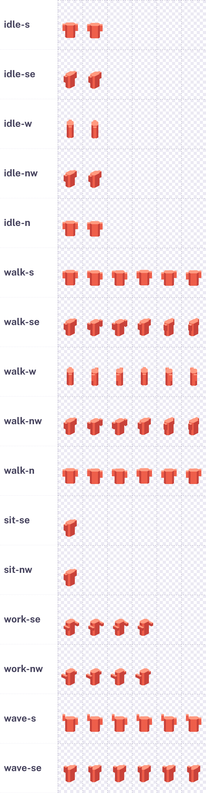 | Bottom · animated layer  bottom-jeans-01 · 384 × 2048 px · 62 frames · 16 tags  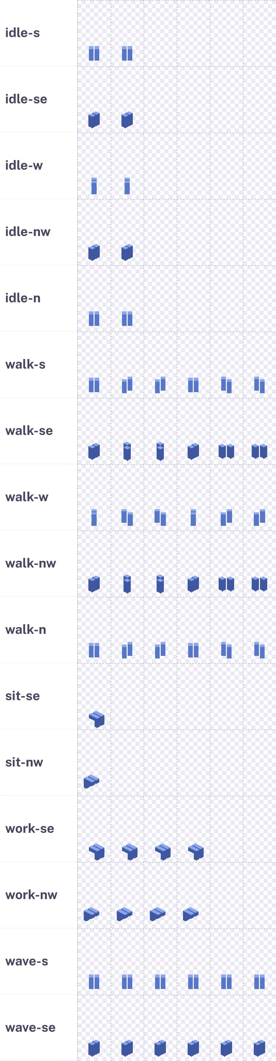 | Footwear · animated layer  shoes-sneaker-01 · 384 × 2048 px · 62 frames · 16 tags  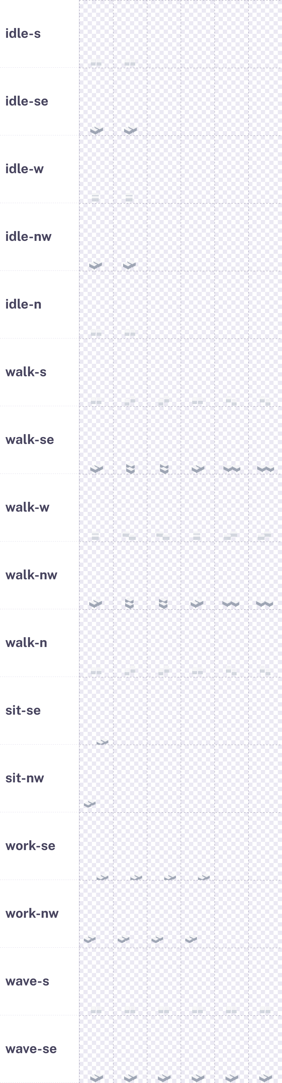

Body · animated layer  body-base-01 · 384 × 2048 px · 62 frames · 16 tags  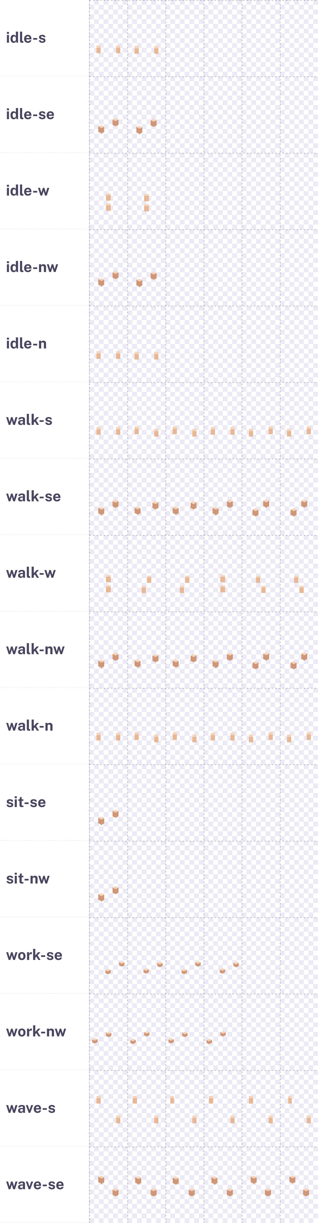 | All layers · review only, not delivered  composite · 384 × 2048 px · 62 frames · 16 tags  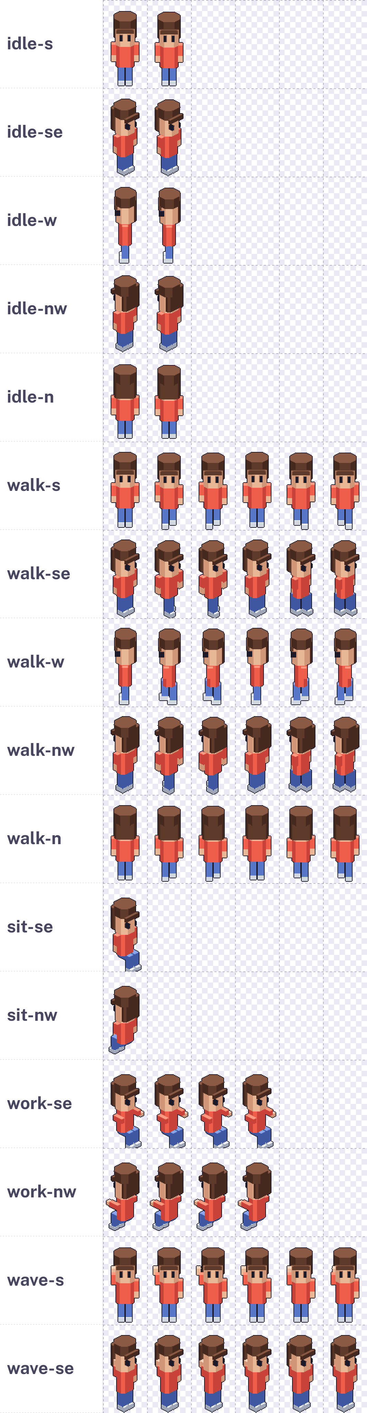 | Head · rigid layer  head-base-01 · 320 × 128 px · 5 frames · 1 tags  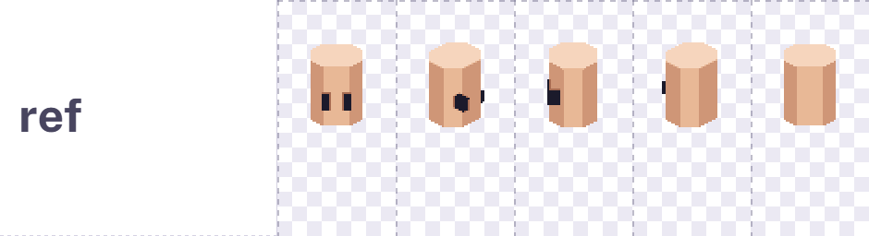  Hair · rigid layer, back + front  hair-bob-01 · 320 × 256 px · 10 frames · 2 tags  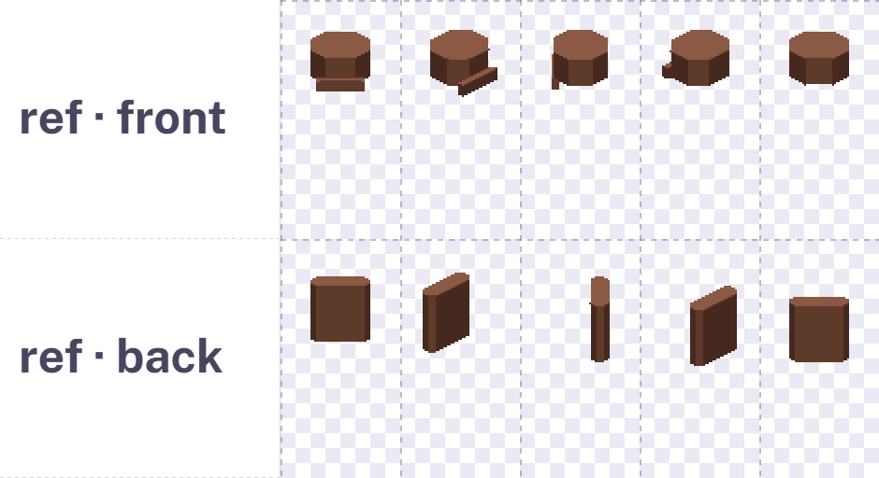

Source files
source/
characters/top-hoodie-01.aseprite
layers art · guide (locked)
slices head (body file only, per frame)
tags idle-s idle-se idle-w idle-nw idle-n
walk-s walk-se walk-w walk-nw walk-n
sit-se sit-nw work-se work-nw
wave-s wave-se
characters/hair-bob-01.aseprite
layers front · back · guide (locked)
tags ref-s ref-se ref-w ref-nw ref-n
furniture/chair-office-01.aseprite
layers base · front · guide (locked)
slices anchor · seat
tags view-se · view-nw
tiles/floor-wood-01.aseprite (4 frames)
walls/wall-plaster.aseprite (tags per piece)

ASSET | ID PATTERN | EXAMPLE
Furniture | {category}-{style}-{nn} | desk-standard-01
Surface prop | prop-{thing}-{nn} | prop-mug-01
Avatar layer | {slot}-{style}-{nn} | hair-bob-01
Floor | floor-{material}-{nn} | floor-wood-01
Wall kit | wall-{material} | wall-glass

R-55 | Deliver the .aseprite source only. Sheets and JSON come out of the build; don't export or lay out sheets by hand.
R-56 | Start every file from the template for its type and footprint. Templates carry the canvas, guide layer, slices and tag names.
R-57 | Names are lowercase, hyphenated, and never change once merged; saved offices store them. Retire an asset by marking it deprecated, never by renaming or deleting it.
R-58 | Tags use {animation}-{direction} for animated avatar layers, ref-{direction} for rigid ones, and view-{direction} (plus -{state}) for furniture. Mirrored directions get no tag.
R-59 | The guide layer stays locked and is hidden at export. Nothing else sits outside the art layers.
R-60 | Every file has an author and licence in its manifest entry before review: commissioned, in-house, or a purchased pack whose licence allows use in a commercial SaaS.

Before you open a pull request
Started from the template; the canvas size is unchanged (R-19, R-56).
Grid edges are clean 2:1 stairs (R-02).
Nothing hangs outside the footprint column or the 64 × 128 frame (R-21, R-37).
Mirrored it in the editor and checked for flipped text, logos and partings (R-16).
Colour-changeable parts use the key ramps (R-43).
Every tag exists with the right frame count; animated layers match the body exactly (R-58, R-62).
Looked at it at 1× next to an avatar (R-09).
Manifest entry has ID, footprint, author and licence (R-60).
Ticks are saved only in this browser, as a personal checklist.
In Word: click a box to tick it. Ticks are saved in your copy of this file.
RULES R-61 TO R-63

How it animates
Aseprite tags are the contract between art and code. The frames, order and frame durations an artist sets are exactly what the game plays.
1  Artist sets tags and timing  One tag per animation and direction (walk-w). Frame durations in Aseprite set the speed: 100 ms per frame is 10 fps. | 2  Build exports sheet + JSON  Aseprite's command line writes the sheet, every frame's rectangle and duration, the tags and the slices. Rigid layers export their 5 reference frames. | 3  Engine creates animations  One Phaser animation per tag, keyed like top-hoodie-01:walk-w, with the exported frame durations.
4  Engine picks the tag  State (idle, walk, sit, work, wave) plus facing from movement. A mirrored direction plays the drawn tag with horizontal flip: e plays walk-w flipped. | 5  Layers play in sync  An avatar is a stack of sprites, one per layer. All animated layers play the same tag and frame. Rigid layers move to the body's head slice on every frame. | 6  Walk speed matches the legs  Walk playback speeds up or slows down with movement speed, so feet don't slide over the floor.

Animation player
In this Word version
On the page this is a live player: a direction pad (drawn directions solid, mirrored ones dashed), buttons for idle, walk, sit, work and wave, layer toggles (body, footwear, bottom, top, head, hair), a "Show the head point" switch and Play, Pause and Next frame. Below is the player as it looks on the page, then every animation in every direction it allows, as animated GIFs with all layers on and the head point shown as an orange dot.

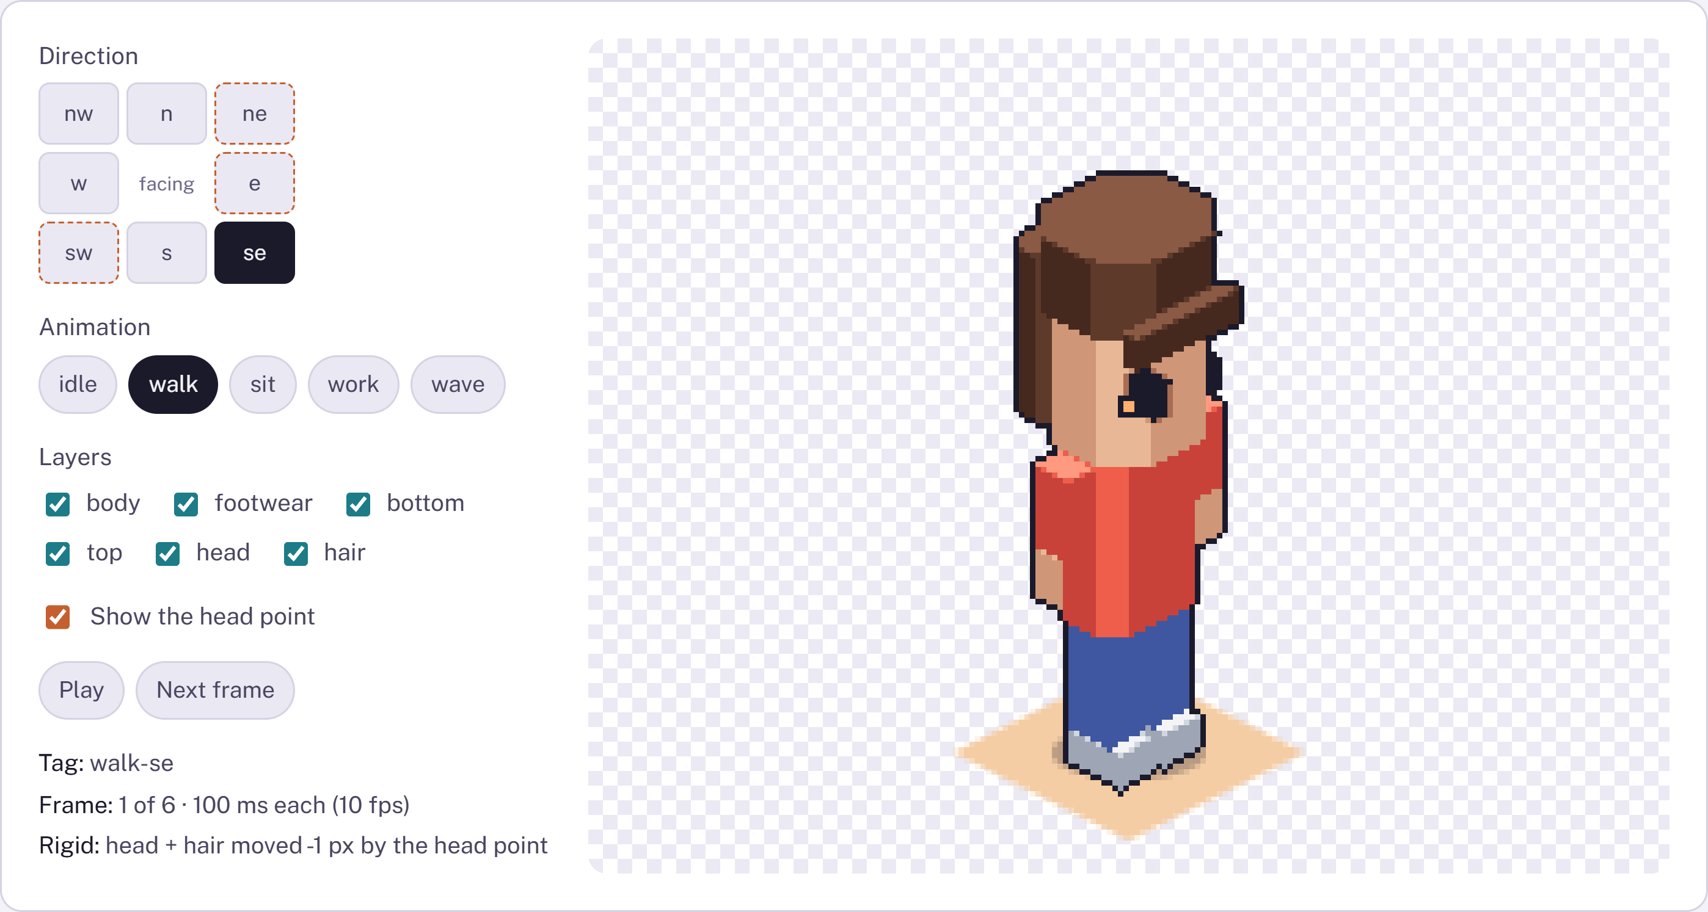
The player on the page, in its default state: walk, facing se.
 | s  drawn | se  drawn | e  mirror | ne  mirror | n  drawn | nw  drawn | w  drawn | sw  mirror
idle  2 frames · 500 ms each (2 fps) | 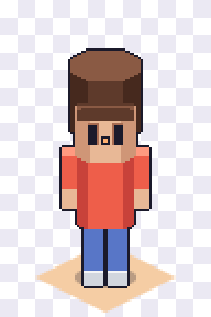  idle-s | 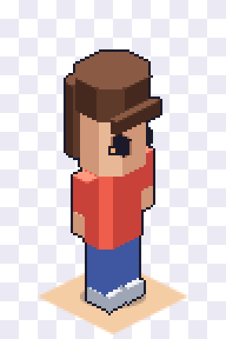  idle-se | 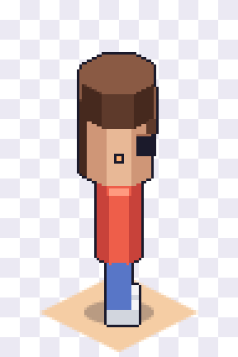  idle-w | 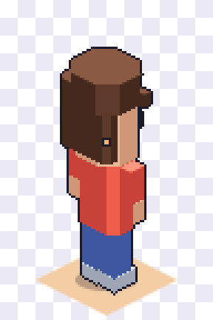  idle-nw | 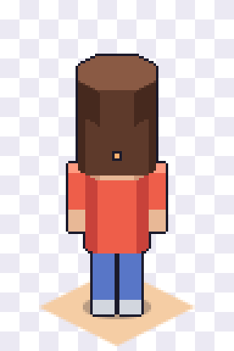  idle-n | 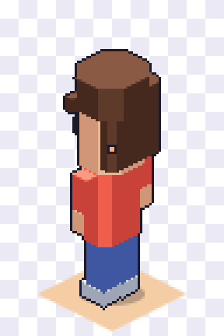  idle-nw | 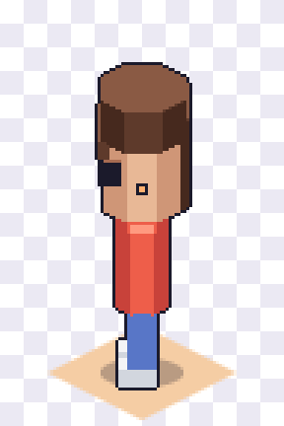  idle-w | 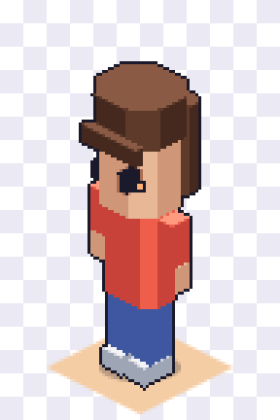  idle-se
walk  6 frames · 100 ms each (10 fps) | 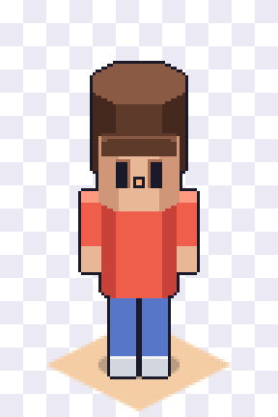  walk-s | 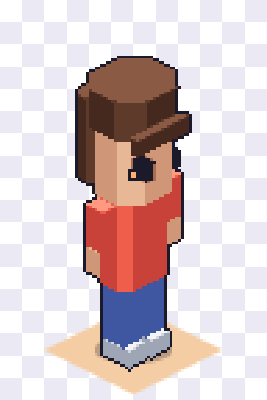  walk-se | 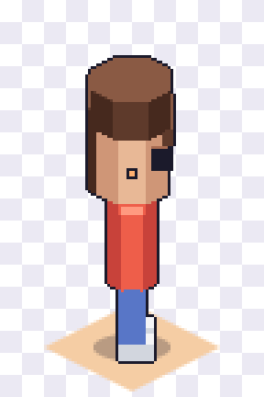  walk-w | 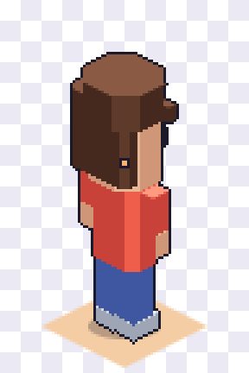  walk-nw | 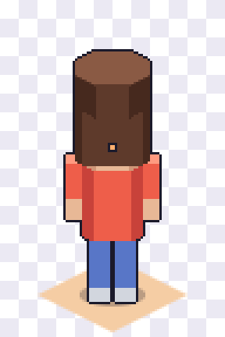  walk-n | 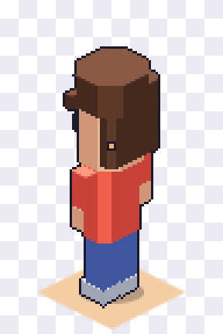  walk-nw | 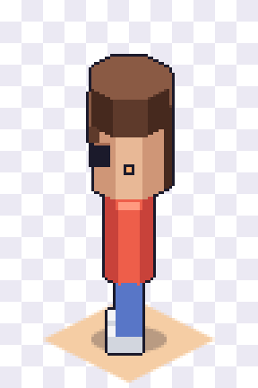  walk-w | 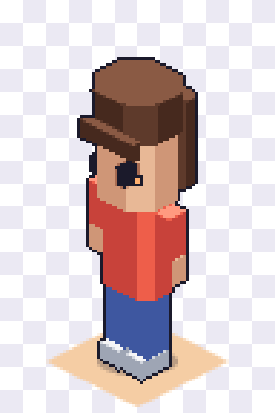  walk-se
sit  1 frame · 1000 ms each (1 fps) | turns to se | 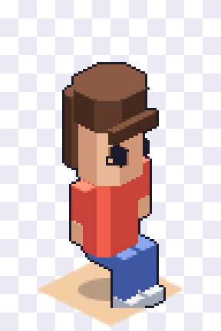  sit-se | turns to se | 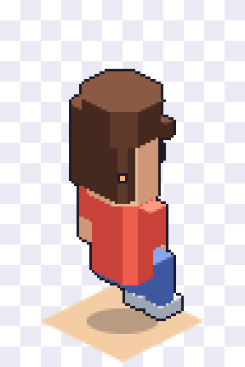  sit-nw | turns to nw | 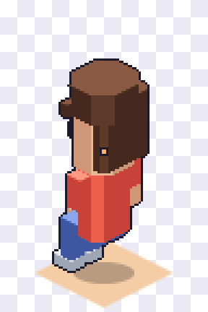  sit-nw | turns to sw | 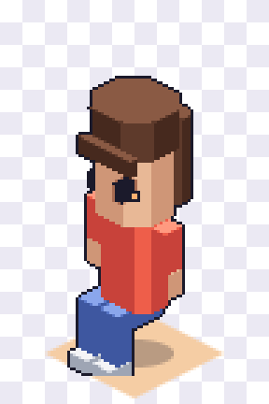  sit-se
work  4 frames · 125 ms each (8 fps) | turns to se | 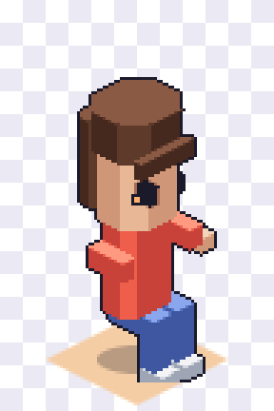  work-se | turns to se | 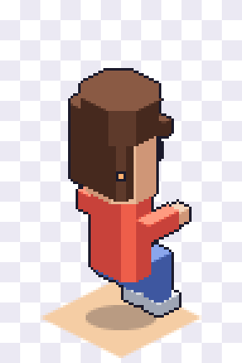  work-nw | turns to nw | 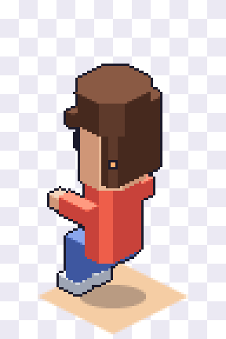  work-nw | turns to sw | 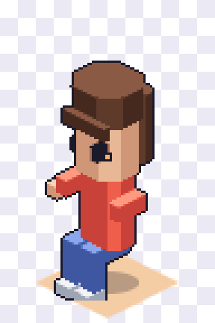  work-se
wave  6 frames · 100 ms each (10 fps) | 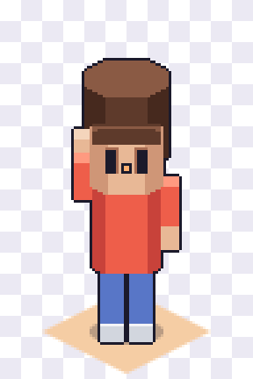  wave-s | 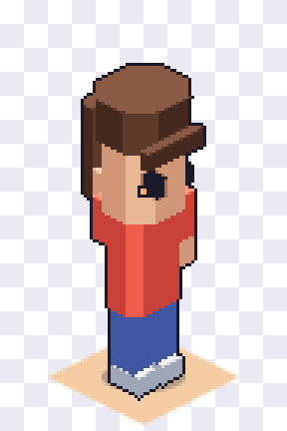  wave-se | turns to se | turns to se | turns to s | turns to sw | turns to sw | 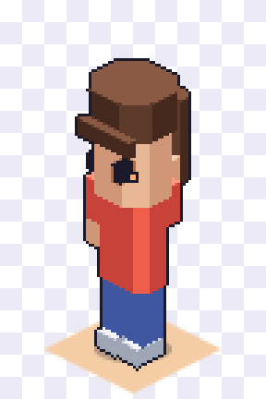  wave-se
Each cell plays the tag shown under it. Orange tags are a drawn tag played flipped for that direction (R-14). Sit and work use only the four tile-edge directions, and wave only the three facing the camera; pick another direction and the avatar turns first, as the page shows.

What the player reports per frame
ANIMATION | FRAMES | EACH FRAME | RIGID LAYERS (HEAD + HAIR) MOVED BY THE HEAD POINT, FRAME BY FRAME
idle | 2 | 500 ms (2 fps) | 1: 0 px · 2: 1 px
walk | 6 | 100 ms (10 fps) | 1: -1 px · 2: 0 px · 3: 0 px · 4: -1 px · 5: 0 px · 6: 0 px
sit | 1 | 1000 ms (1 fps) | 1: 6 px
work | 4 | 125 ms (8 fps) | 1: 6 px · 2: 6 px · 3: 6 px · 4: 6 px
wave | 6 | 100 ms (10 fps) | 1: 0 px · 2: 0 px · 3: 0 px · 4: 0 px · 5: 0 px · 6: 0 px

R-61 | Frame durations in Aseprite are the timing the game uses. Set them on the tag's frames, not in a note.
R-62 | Every animated layer option has exactly the same tags, frame counts and durations as the body, or the layers drift apart.
R-63 | Loops loop cleanly: the last frame leads into the first. wave plays once and ends on a pose that returns to idle.
PLANNING

MVP asset list
The board lists far more than an MVP needs. This is the office set to draw first, with each item's footprint and height under these rules. IDs in the last column already exist in the builder as placeholders.
GROUP | ITEM | FOOTPRINT | HEIGHT | VIEWS | CATALOG ID TODAY
Floors | Wood, carpet, concrete, ceramic tile (4 variants each) | Tile | 0 | 1, mirror for direction | —
Walls | Plaster kit, glass kit | Edge | 128 / 16 | / drawn, \ mirrored | —
Walls | Low partition | 2 × 1 | 40 | 2 drawn | wall-partition-01
Desks | Standard desk | 2 × 1 | 32 | 2 drawn | desk-standard-01
Desks | L-shaped desk | 2 × 2 | 32 | 4 drawn (mirror: false) | desk-corner-01
Desks | Standing desk | 1 × 1 | 52 | 2 drawn | desk-standing-01
Seating | Office swivel chair (base + front) | 1 × 1 | 52 | 2 drawn | chair-office-01
Seating | Lounge armchair, 2-seat sofa, beanbag | 1 × 1, 2 × 1, 1 × 1 | 44, 40, 24 | 2 drawn | chair-lounge-01
Tables | Conference table (low, so no slicing) | 3 × 2 | 32 | 2 drawn | table-conference-01
Tables | Round table, coffee table, café table | 2 × 2, 1 × 1, 1 × 1 | 32, 16, 32 | 1 (symmetric) | table-round-01, table-coffee-01
Storage | Bookshelf, locker (against wall) | 2 × 1, 1 × 1 | 104 | 2 drawn | storage-bookshelf-01
Storage | Drawer unit, low shelf | 1 × 1, 2 × 1 | 32, 40 | 2 drawn | storage-cabinet-01
Kitchen | Counter, fridge (against wall), water dispenser | 2 × 1, 1 × 1, 1 × 1 | 44, 104, 72 | 2 drawn | —
Plants | Medium floor plant, tall floor plant | 1 × 1 | 56, 104 | 1 (mirror freely) | plant-potted-01, plant-tall-01
Decor | Rugs small, medium, large (decals) | 1 × 1, 2 × 2, 3 × 2 | 2 | 1 | decor-rug-01
Wall items | Wall TV, whiteboard, poster, clock | 2, 2, 1, 1 segments | — | / drawn, \ mirrored | electronics-tv-01, decor-whiteboard-01
Surface props | Monitor, laptop, mug, notebook, pen holder, desk plant, book stack | Prop | ≤ 32 | 2 drawn | electronics-monitor-01 (moves to props)

Avatar MVP (board's Essential list)  One neutral body · one head · 6 skin tones · 10 hairstyles · 13 hair colours · 4 facial hair · 6 tops · 4 bottoms · 3 footwear · 3 headgear · 2 eyewear · idle, walk, sit, work and wave. | Later scenes  Apartment, classroom, stage event, convention stalls, town and travel screen are on the board. Town and travel need their own scale (likely half size) and get a rulebook section when they're scheduled.
PLANNING

Decisions for approval
Each of these changes the art or the engine. Once they're settled, this page moves into the Hosting & Scale Plan as its art spec.
- Office default zoom at 1×. The board puts the office at mid and max zoom-out. At 1× the whole default office fits a laptop screen and a standing avatar is 96 px tall.
- Tile size 64 × 32. Matches the board and Habbo. The backend default changes from 96 × 48; existing seeded offices need a reseed.
- Walk at 6 frames. Saves 10 frames per animated layer option compared with 8. Raise it to 8 later if it looks stiff.
- Head, hair, hats and glasses as rigid layers. Cuts avatar art roughly in half, but needs the engine to read the per-frame head slice.
- Walls on tile edges. Needs a wall layer in the engine. The fallback is walls as one-tile furniture, which makes rooms thicker and cut-away harder.
- Surface props in stage 1. Until then, desk items are baked into a few desk variants.
- Against-wall rule for items over 112 px. Keeps open floors readable but limits where admins can place tall items.
- Light direction (art lead). Front or top light keeps mirrored views correct; side light needs extra drawn views or accepting the flip.

